Oxford International Benenden School — summer school in the UK

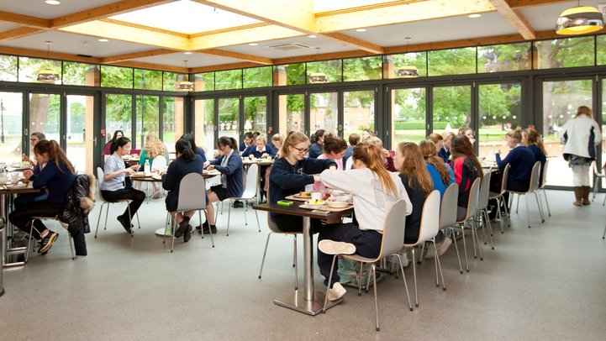

Benenden, Cranbrook, UK, from 9 to 17 age

Course intensity | 15
Accommodation | Campus
Room type | Multi-bedded
Bathroom facilities | Shared
Meals | Breakfast, Lunch and Dinner
Excursions per week | 3
Weekday excursions | 2
Full day excursions | 1

Description

Why choose this program

Infrastructure

Sport infrastructure

Hobbies and clubs

What else included in the program price

Recommended arrival city

Лондон

Sample timetable
 | Morning | Afternoon | Evening
Day 1 | Arrivals | Arrivals | Campus tour and ice-breaker activities
Day 2 | Placement Test and Lesson 1 | Half day excursion to Royal Tunbridge Wells | Onsite Activities
Day 3 | Lesson 2 | Onsite Activities | Welcome Disco
Day 4 | Lesson 3 | iPad Treasure Hunt | Karaoke/Lip Sync Battle
Day 5 | Lesson 4 | Onsite Activities | Onsite Activities
Day 6 | Lesson 5 | Onsite Activities | International Evening
Day 7 | Full day excursion to Canterbury | Entrance to Canterbury Cathedral | Onsite Activities
Day 8 | On-site Activities | Lesson | Disco
Day 9 | Full day excursion to London | Full day excursion to London | Full day excursion to London
Day 10 | Lesson | Lesson | On-site Activities
Day 11 | Lesson | Lesson | On-site Activities
Day 12 | On-site Activities | Lesson | Talent Show
Day 13 | Full day excursion to Brighton | Full day excursion to Brighton | Full day excursion to Brighton
Day 14 | Optional Excursion | Optional Excursion | On-site Activities

For booking please go to www.travelclass.org

