Centre International d'Antibes Horticole — language school in France

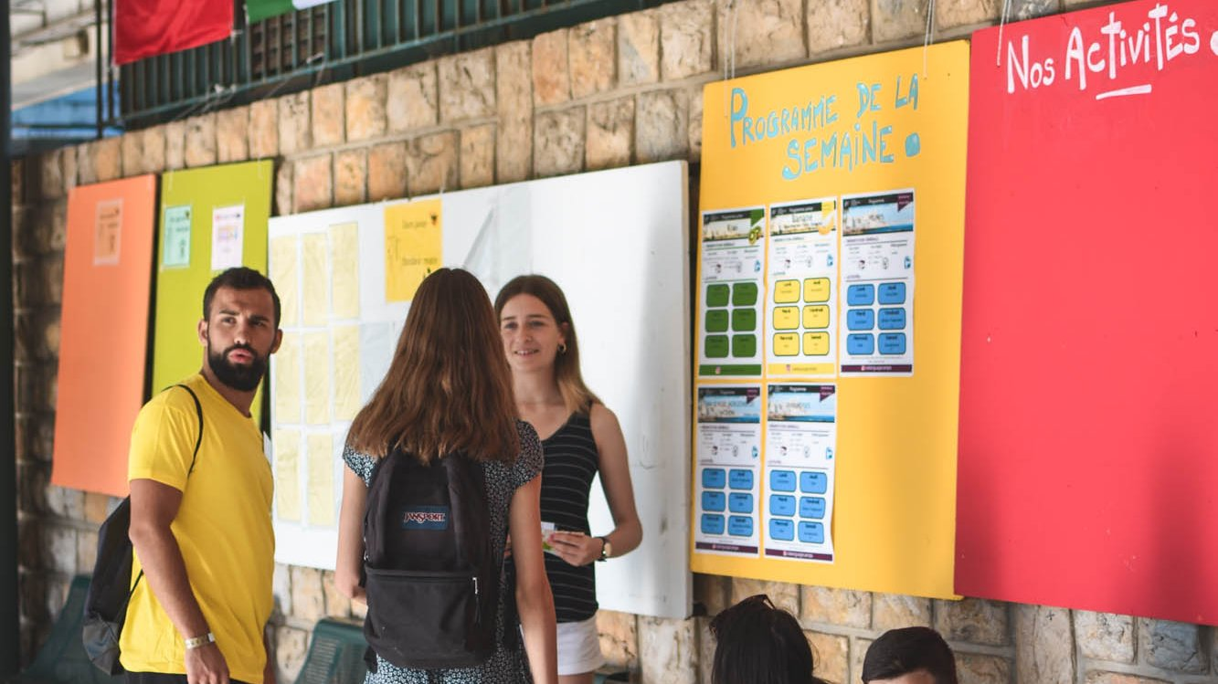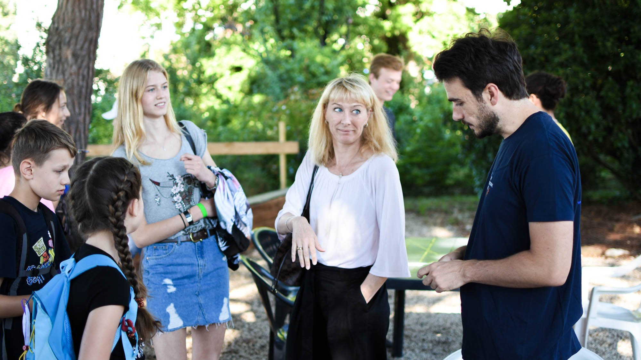

1285 Avenue Jules Grec, Antibes, France, from 8 to 12 age

Course intensity | 15
Accommodation | Campus
Room type | Multi-bedded
Bathroom facilities | Shared
Meals | Breakfast, Lunch and Dinner
Excursions per week | 2
Weekday excursions
Full day excursions | 1

Description

Why choose this program

Infrastructure

Sport infrastructure

Hobbies and clubs

What else included in the program price

Recommended arrival city

Ницца

Sample timetable
 | Morning | Afternoon | Evening
Day 1 | French lessons | City tour | Barbeque evening
Day 2 | French lessons | Free afternoon | Casino evening
Day 3 | French lessons | Sailing afternoon | Film evening
Day 4 | French Lessons | Visit to Monaco | Cabaret
Day 5 | French lessons | Sports afternoon | Disco evening
Day 6 | Departure
Day 7

For booking please go to www.travelclass.org

