Ardmore Eastbourne Campus University of Brighton — summer school in the UK

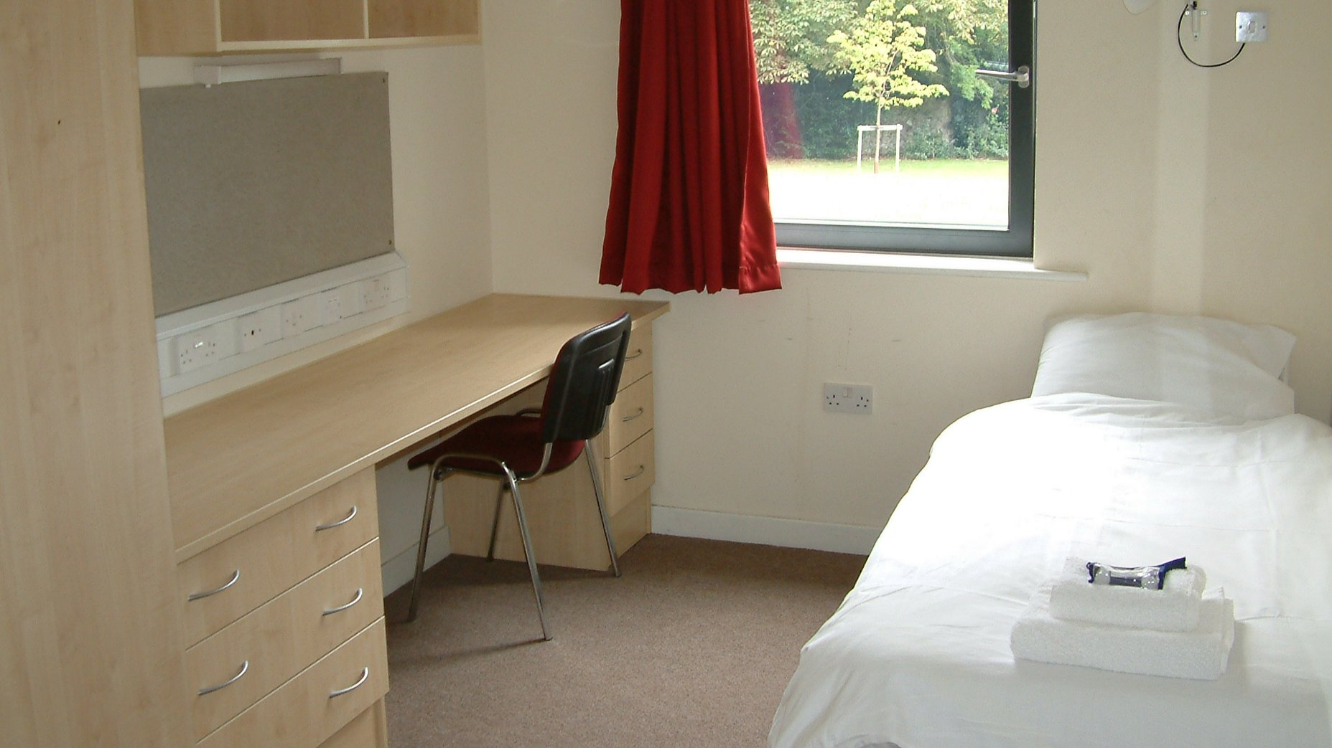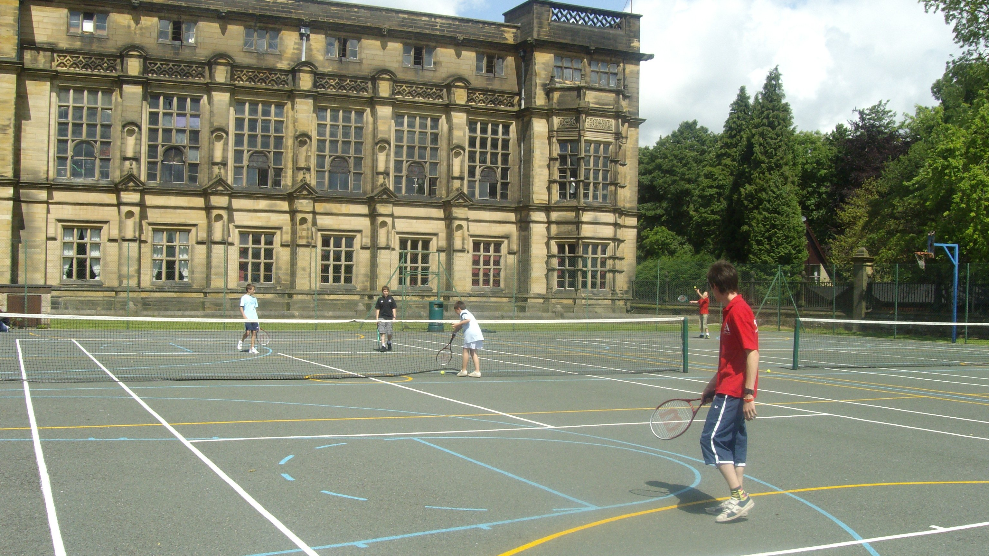

University of Brighton Sports Centre, Brighton, UK, from 9 to 17 age

Course intensity | 15
Accommodation | Campus
Room type | Single
Bathroom facilities | En-suite
Meals | Breakfast, Lunch and Dinner
Excursions per week | 3
Weekday excursions | 2
Full day excursions | 1

Description

Why choose this program

Infrastructure

Sport infrastructure

Hobbies and clubs

What else included in the program price

Recommended arrival city

Лондон

Sample timetable
 | Morning | Afternoon | Evening
Day 1 | Arrival | Arrival | Arrival
Day 2 | Lessons | Orientation of Eastbourne (walking) | Welcome Icebreaker Games
Day 3 | Lessons | Sports & Leisure Activities | quiz games
Day 4 | Lessons | Half Day Excursion to Brighton Pier and Lanes | Talent Show
Day 5 | Lessons | Eastbourne Town Trial (walking) | Casino Night
Day 6 | Lessons | Sports and Leisure Activities | Disco
Day 7 | Full Day Excursion to Portsmouth, Spinnaker Tower and Gun Wharf Quays | Full Day Excursion to Portsmouth, Spinnaker Tower and Gun Wharf Quays | Sports Tournament
Day 8 | Sports and Leisure Activities on Campus / Optional Extra Excursions | Sports and Leisure Activities on Campus / Optional Extra Excursions | Movie Night
Day 9 | Lessons | Beach Adventure (walking) | Capture the Flag
Day 10 | Lessons | Sports & Leisure Activities | Find Dr Ardmore
Day 11 | Lessons | Half Day Excursion to Brighton i360 | Karaoke
Day 12 | Lessons | Sports & Leisure Activities | Rounders
Day 13 | Lessons | Sports & Leisure Activities | Disco
Day 14 | Full Day Excursion to London, Thames River Cruise and Westminster Walking Tour | Full Day Excursion to London, Thames River Cruise and Westminster Walking Tour | Mini Olympics

For booking please go to www.travelclass.org

