Ardmore Brunel University — summer school in the UK

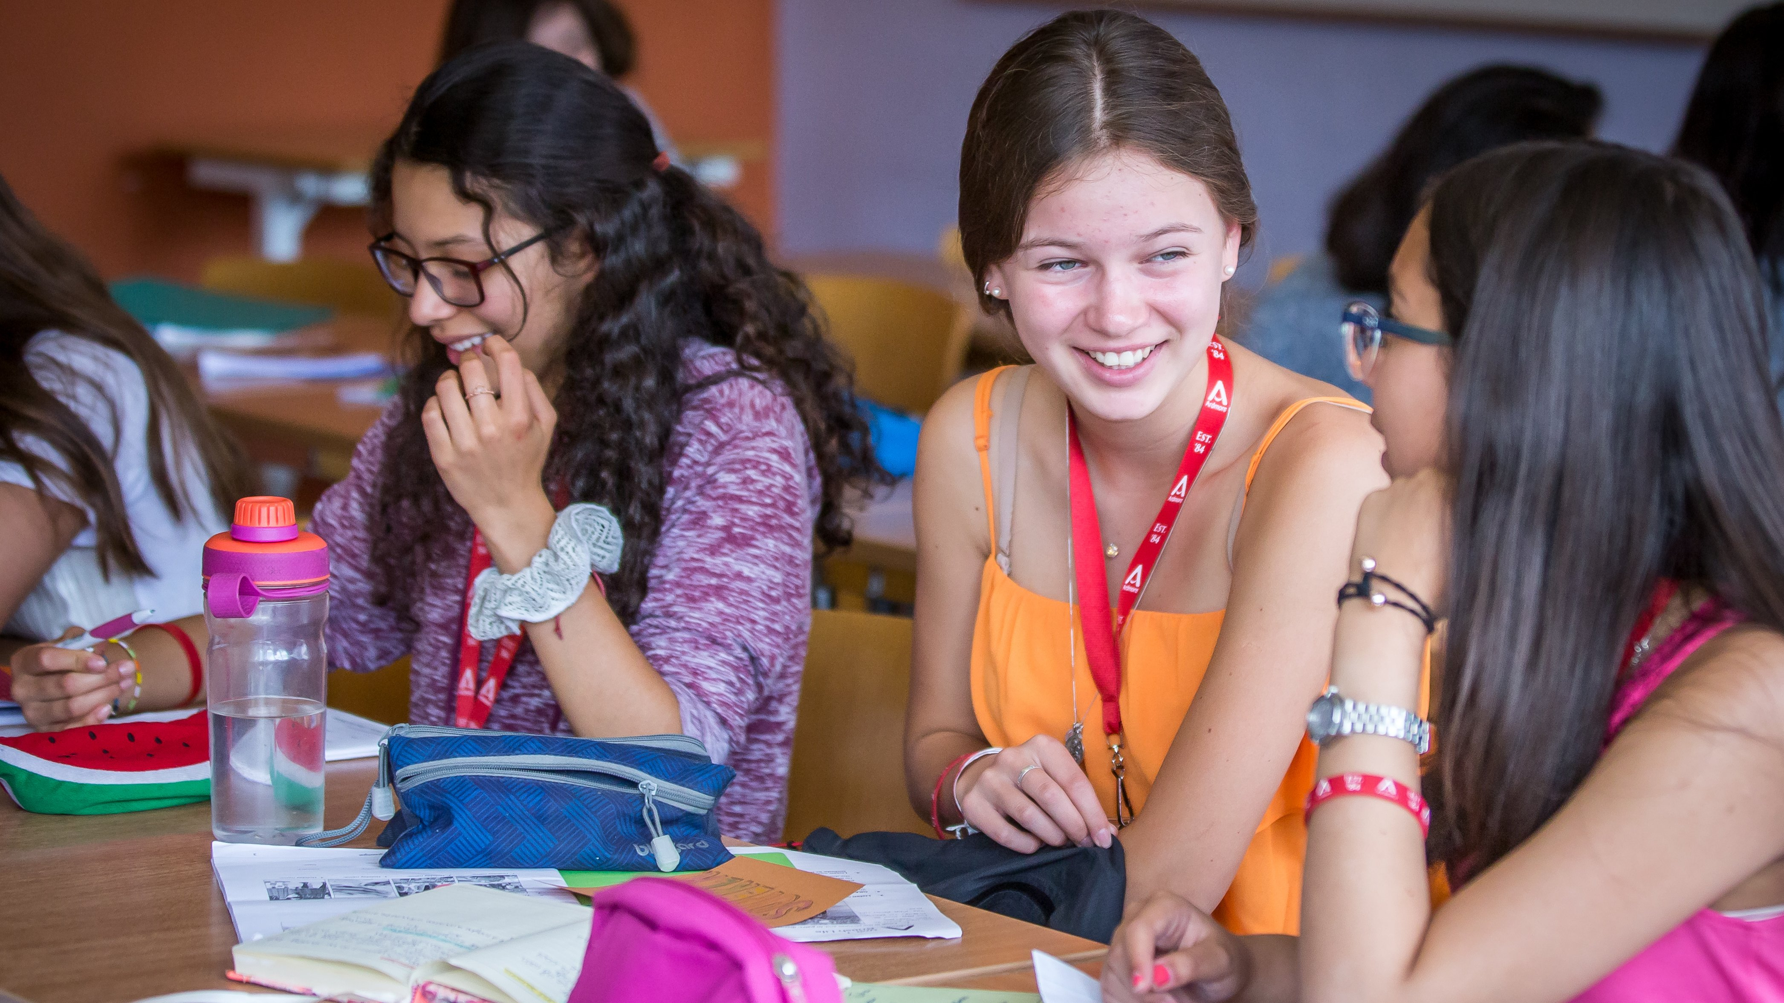

Brunel University, Uxbridge, UK, from 9 to 17 age

Course intensity | 15
Accommodation | Campus
Room type | Single
Bathroom facilities | En-suite
Meals | Breakfast, Lunch and Dinner
Excursions per week | 3
Weekday excursions | 2
Full day excursions | 1

Description

Why choose this program

Infrastructure

Sport infrastructure

Hobbies and clubs

What else included in the program price

Recommended arrival city

Лондон

Sample timetable
 | Morning | Afternoon | Evening
Day 1 | Arrival | Arrival | Arrival
Day 2 | Lessons | Sports & Leisure Activities | Welcome Icebreaker Games
Day 3 | Lessons | Half Day Excursion to Natural History Museum | Egg Protector
Day 4 | Lessons | Lessons | Talent Show
Day 5 | Full Day Excursion to London, Thames River Cruise and Westminster Walking Tour | Full Day Excursion to London, Thames River Cruise and Westminster Walking Tour | Sports Tournament
Day 6 | Lessons | Sports and Leisure Activities | Disco
Day 7 | Full Day Excursion to Oxford, Oxford Universities Walking Tour | Full Day Excursion to Oxford, Oxford Universities Walking Tour | Sports Tournament
Day 8 | Sports and Leisure Activities on Campus / Optional Extra Excursions | Sports and Leisure Activities on Campus / Optional Extra Excursions | Movie Night
Day 9 | Sports & Leisure Activities | Lessons | Capture the Flag
Day 10 | Half Day Excursion to Westfields Shopping Centre | Lessons | Find Dr Ardmore
Day 11 | Lessons | Lessons | Karaoke
Day 12 | Full Day Excursion to Windsor, Windsor Castle and Eton Walking Tour | Full Day Excursion to Windsor, Windsor Castle and Eton Walking Tour | Rounders
Day 13 | Sports & Leisure Activities | Lessons | Disco
Day 14 | Breakfast | Departure | Departure

For booking please go to www.travelclass.org

