IP Winchester — summer school in the UK

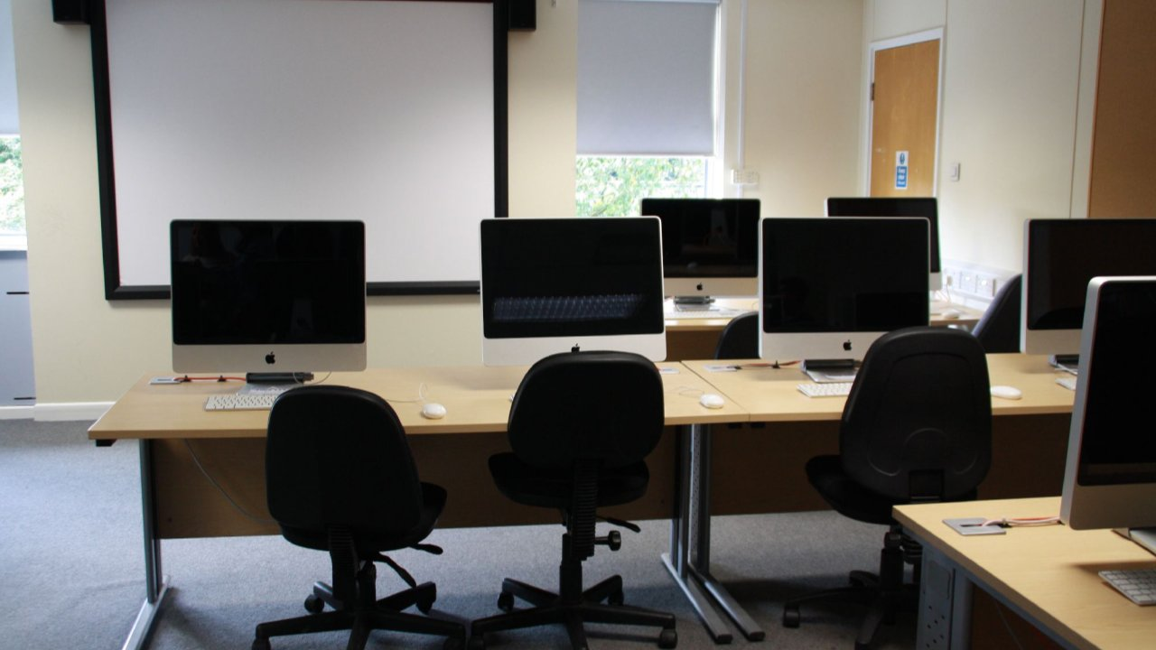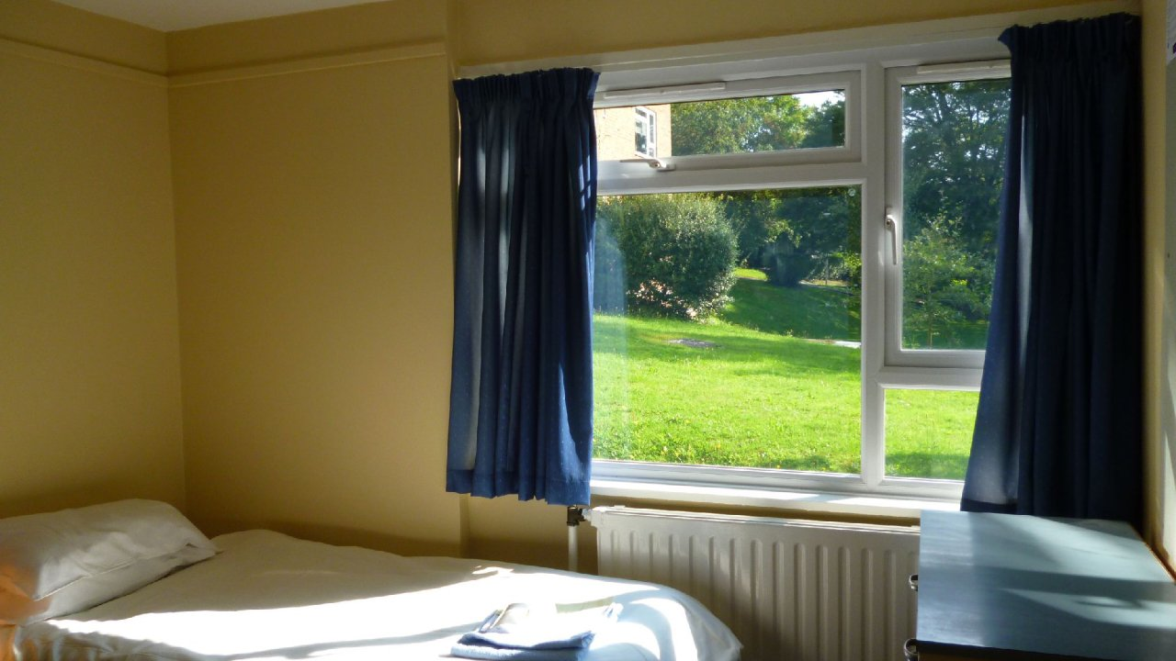

Winchester, Винчестер, UK, from 10 to 17 age

Course intensity | 15
Accommodation | Résidence
Room type | Single
Bathroom facilities | Shared
Meals | Breakfast, Lunch and Dinner
Excursions per week | 1
Weekday excursions | 1
Full day excursions

Description

Why choose this program

Infrastructure

Sport infrastructure

Hobbies and clubs

What else included in the program price

Recommended arrival city

Лондон

Sample timetable
 | Morning | Afternoon | Evening
Day 1 | Meet & greet | Chill out | Movie Night
Day 2 | Lessons | Orientation Walk and Free Time in Town | Capture the Flag / Escape Room
Day 3 | Lessons | Free afternoon | St Catherines Hill Sunset Hike / Quiz Night
Day 4 | Lessons | Free afternoon | Winchester by Night
Day 5 | Lessons | Afternoon activity and Winchester Cathedral | Werewolves
Day 6 | Lessons | Graduation Ceremony/ Souvenir Shopping in town | Just Dance Party
Day 7 | Breakfast | Departure

For booking please go to www.travelclass.org

