IP Bournemouth - language school in the UK

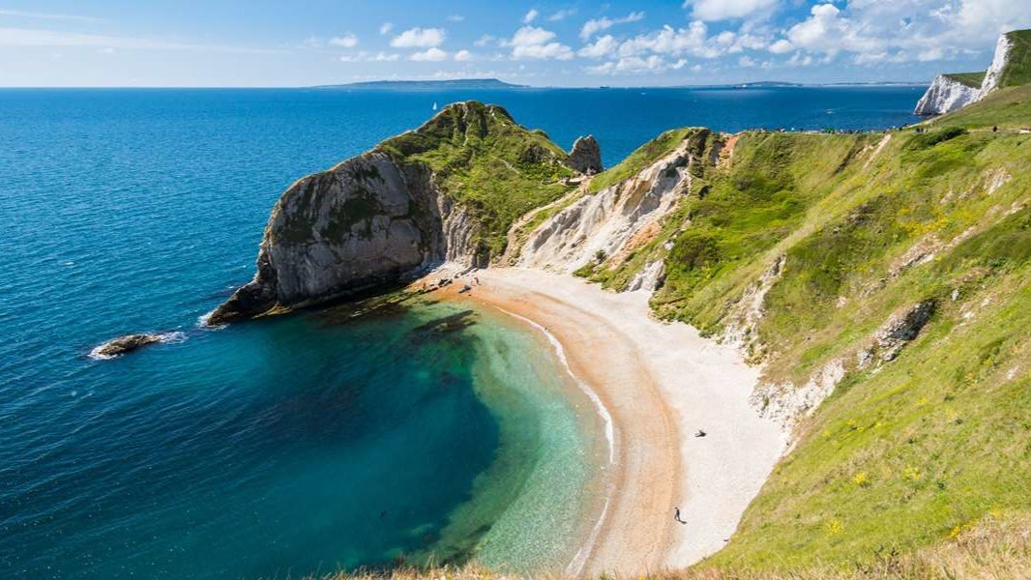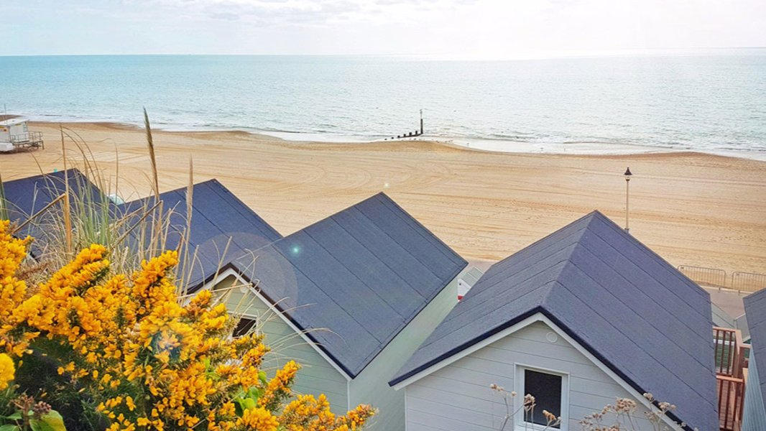

Europa School of English, Knole Road, Bournemouth, UK, from 11 to 17 age

Course intensity | 15
Accommodation | Host family
Room type | Twin
Bathroom facilities | Shared
Meals | Breakfast, Lunch and Dinner
Excursions per week | 0
Weekday excursions | 0
Full day excursions | 0

Description

Why choose this program

Infrastructure

Sport infrastructure

Hobbies and clubs

What else included in the program price

Recommended arrival city

Лондон

Sample timetable
 | Morning | Afternoon | Evening
Day 1 | Arrival in the UK | Welcome Meeting | Chill'n'Relax
Day 2 | Lessons of English | Orientation Tour | Free evening with your GLs
Day 3 | Lessons of English | Free afternoon with your GLs | Free evening with your GLs
Day 4 | Lessons of English | Indoor Cinema | Free evening with your GLs
Day 5 | Lessons of English | Free afternoon with your GLs | Free evening with your GLs
Day 6 | Lessons of English | Graduation & Cream Tea | Free evening with your GLs
Day 7 | Free morning with your  Group Leaders | Departure

For booking please go to www.travelclass.org

