UKLC York St Peter's School — summer school in the UK

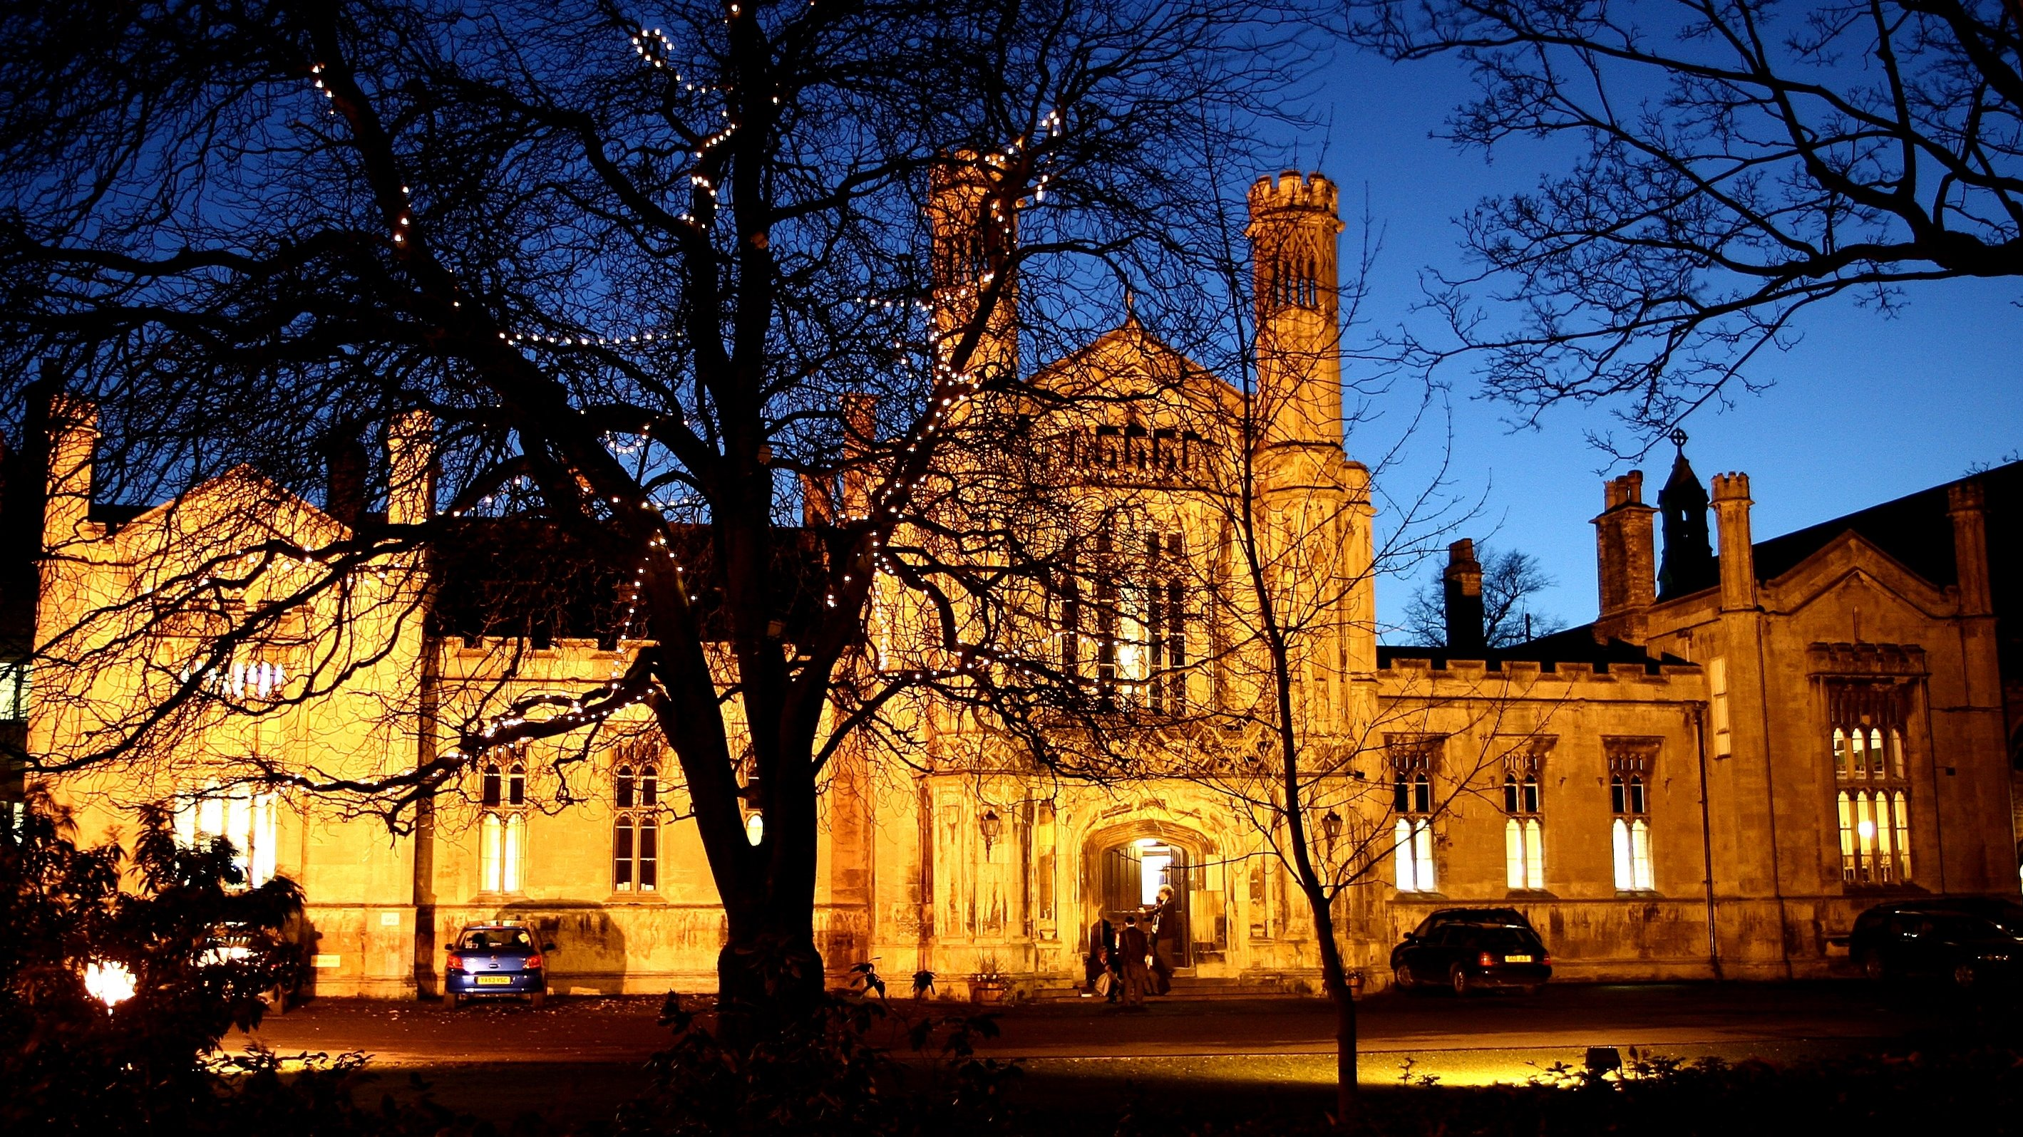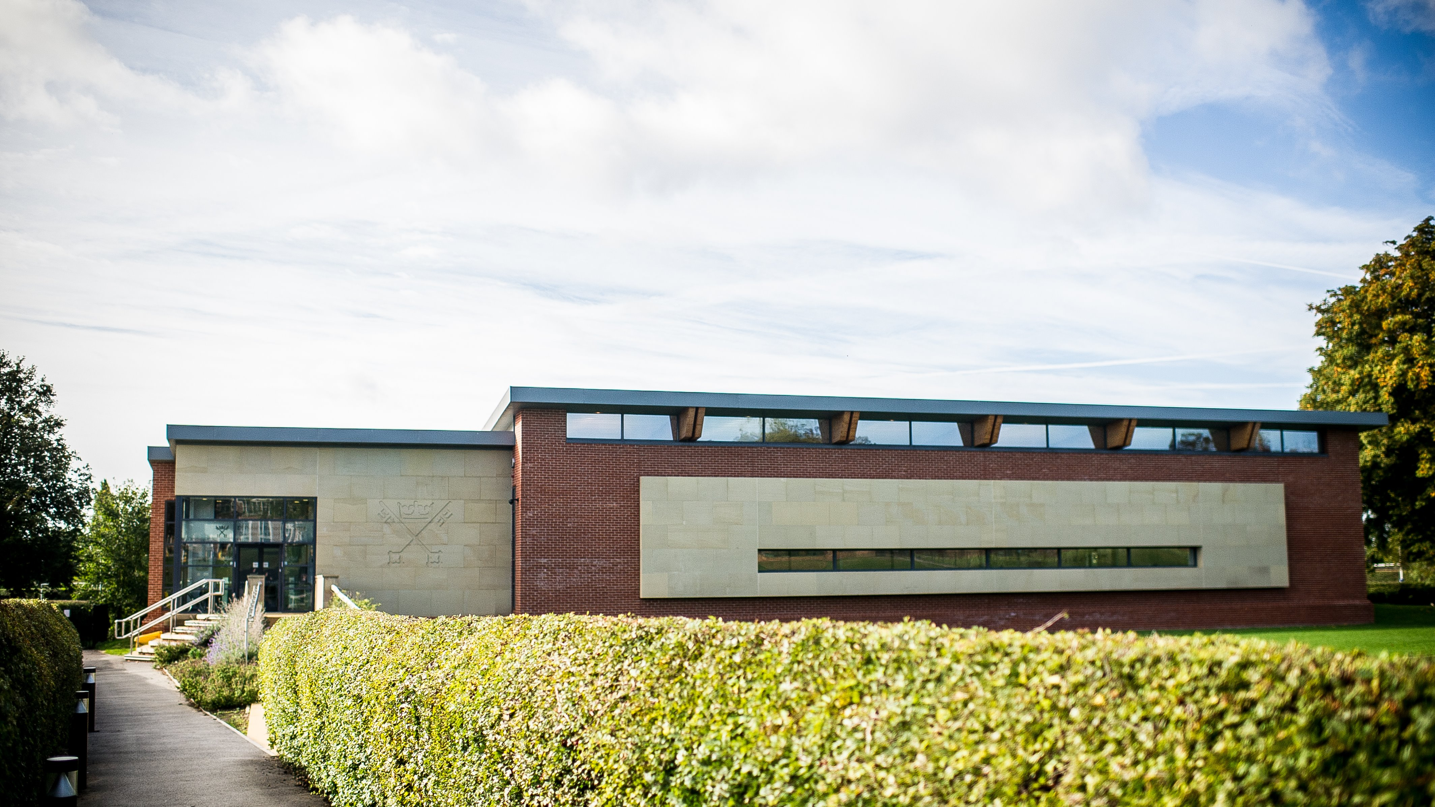

St Peters School, St Peters Pre Prep School, York, UK, from 8 to 17 age

Course intensity | 15
Accommodation | Campus
Room type | Multi-bedded
Bathroom facilities | Shared
Meals | Breakfast, Lunch and Dinner
Excursions per week | 3
Weekday excursions | 1
Full day excursions | 2

Description

Why choose this program

Infrastructure

Sport infrastructure

Hobbies and clubs

What else included in the program price

Recommended arrival city

Лидс

Sample timetable
 | Morning | Afternoon | Evening
Day 1 | English Test | Multi Activity or Chosen Programme | Message Disco
Day 2 | English Lessons | York with York Dungeons | Around the World or Conversation Club
Day 3 | English Lessons | Multi Activity or Chosen Programme | Mini Olympics
Day 4 | English Lessons | Leeds with Leeds City Museum | Ghost Walk or Conversation Club
Day 5 | English Lessons | Multi Activity or Chosen Programme | Karaoke
Day 6 | Whitby with Bark Endeavour | Whitby with Bark Endeavour | Film Night
Day 7 | English Lessons | Multi Activity or Chosen Programme | Campus Monopoly
Day 8 | English Lessons | Full day excursion to York & Railway Museum | Speed Dating
Day 9 | English Lessons | Multi Activity or Chosen Programme | Paparazzi
Day 10 | English Lessons | Castle Howard | Trashion show
Day 11 | English Lessons | Multi Activity or Chosen Programme | Dinner
Day 12 | Manchester with Man UTD OLD Trafford Tour | Manchester with Man UTD OLD Trafford Tour | Manchester with Man UTD OLD Trafford Tour
Day 13 | Free time, activities and optional excursion | Free time, activities and optional excursion | Free time, activities and optional excursion
Day 14 | Depart

For booking please go to www.travelclass.org

