ILSC Brisbane — School of English in Australia

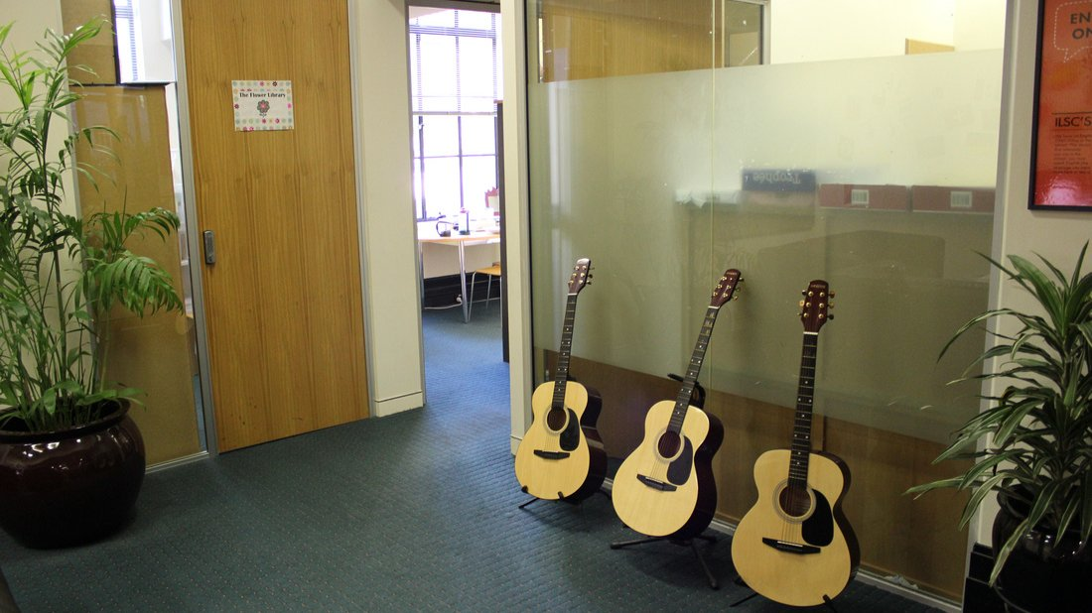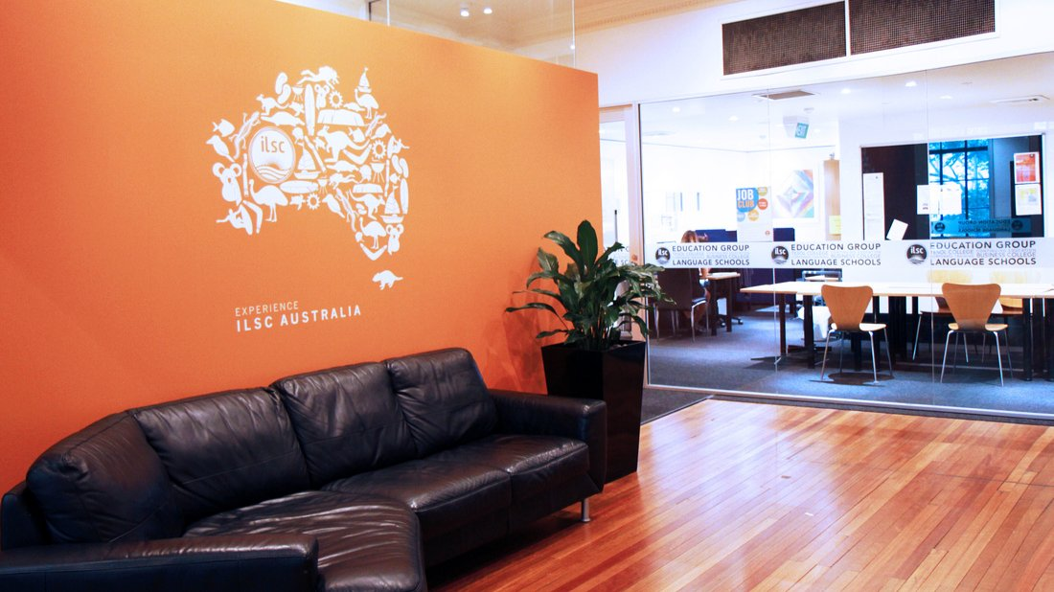

232 Adelaide Street, Brisbane City QLD, Australia, from 16 to 99 age

Course intensity | 17
Accommodation | Host family
Room type | Single
Bathroom facilities | Shared
Meals | Breakfast, Lunch and Dinner
Excursions per week | 6
Weekday excursions | 5
Full day excursions | 1

Description

Why choose this program

Infrastructure

Sport infrastructure

Hobbies and clubs

What else included in the program price

Recommended arrival city

Брисбен

Sample timetable
 | Morning | Afternoon | Evening
Day 1 | English classes till 12:00 | Kangaroo Point Walking Tour | Free time
Day 2 | English classes till 12:00 | Kayak the River City | Free time
Day 3 | English classes till 12:00 | Tree Top Walk | Free time
Day 4 | English classes till 12:00 | Museum of Brisbane | Free time
Day 5 | English classes till 12:00 | Lone Pine Koala Sanctuary | Free time
Day 6 | Warner Bros. Movie World | Warner Bros. Movie World | Warner Bros. Movie World
Day 7 | Free time with your host family and group | Free time with your host family and group | Free time with your host family and group
Day 8 | English classes | CityCat of Brisbane River | Homestay
Day 9 | English classes | Stand-up Paddle Boarding | Homestay
Day 10 | English classes | Mount Coot-tha Lookout Tour | Homestay
Day 11 | English classes | Gallery of Modern Art | Homestay
Day 12 | English classes | Streets Beach | Homestay
Day 13 | Australia Zoo | Australia Zoo | Australia Zoo
Day 14 | Departure

For booking please go to www.travelclass.org

