Lexis Seoul - language school in Korea

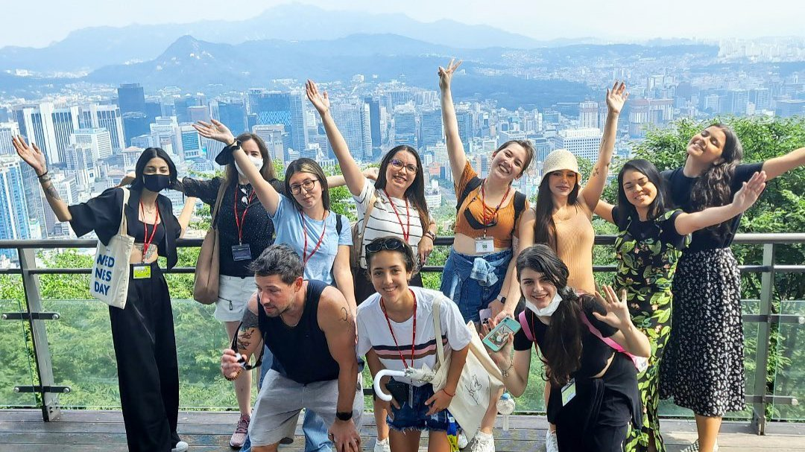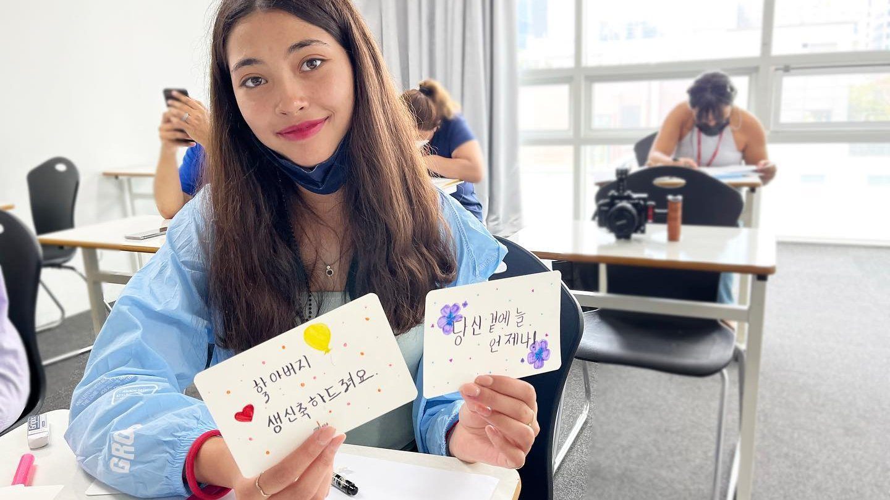

ANYTOWER, Gangnam-daero 53-gil, Seocho-gu, Seoul, South Korea, from 13 to 17 age

Course intensity | 15
Accommodation | Host family
Room type | Single
Bathroom facilities | Shared
Meals | Breakfast, Lunch and Dinner
Excursions per week | 1
Weekday excursions | 1
Full day excursions | 1

Description

Why choose this program

Infrastructure

Sport infrastructure

Hobbies and clubs

What else included in the program price

Recommended arrival city

Сеул

Sample timetable
 | Morning | Afternoon | Evening
Day 1 | Korean Lesson | Gangnam Tour | Evening with host family
Day 2 | Korean Lesson | K-Star Road | An evening with a host family
Day 3 | Korean Lesson | Lotte World Aquarium | An evening with a host family
Day 4 | Korean Lesson | Tae Kwon Do | An evening with a host family
Day 5 | Korean Lesson | K-pop dance | An evening with a host family
Day 6 | Optional excursion | Optional excursion | An evening with a host family
Day 7 | Optional excursion | Optional excursion | An evening with a host family

For booking please go to www.travelclass.org

