Chelmsford Writtle University College — language school in the UK

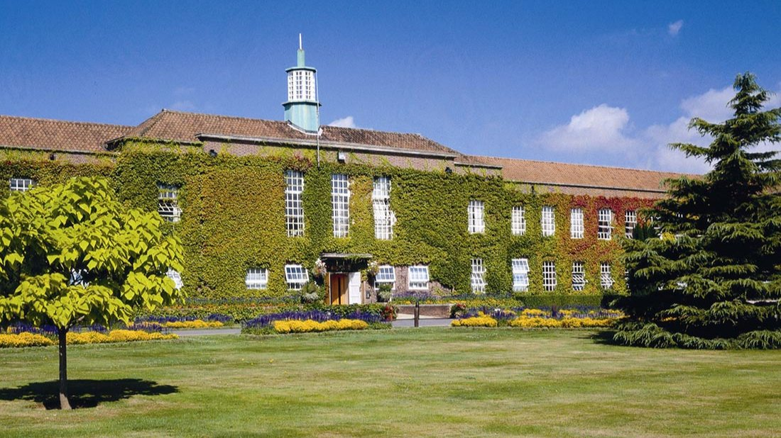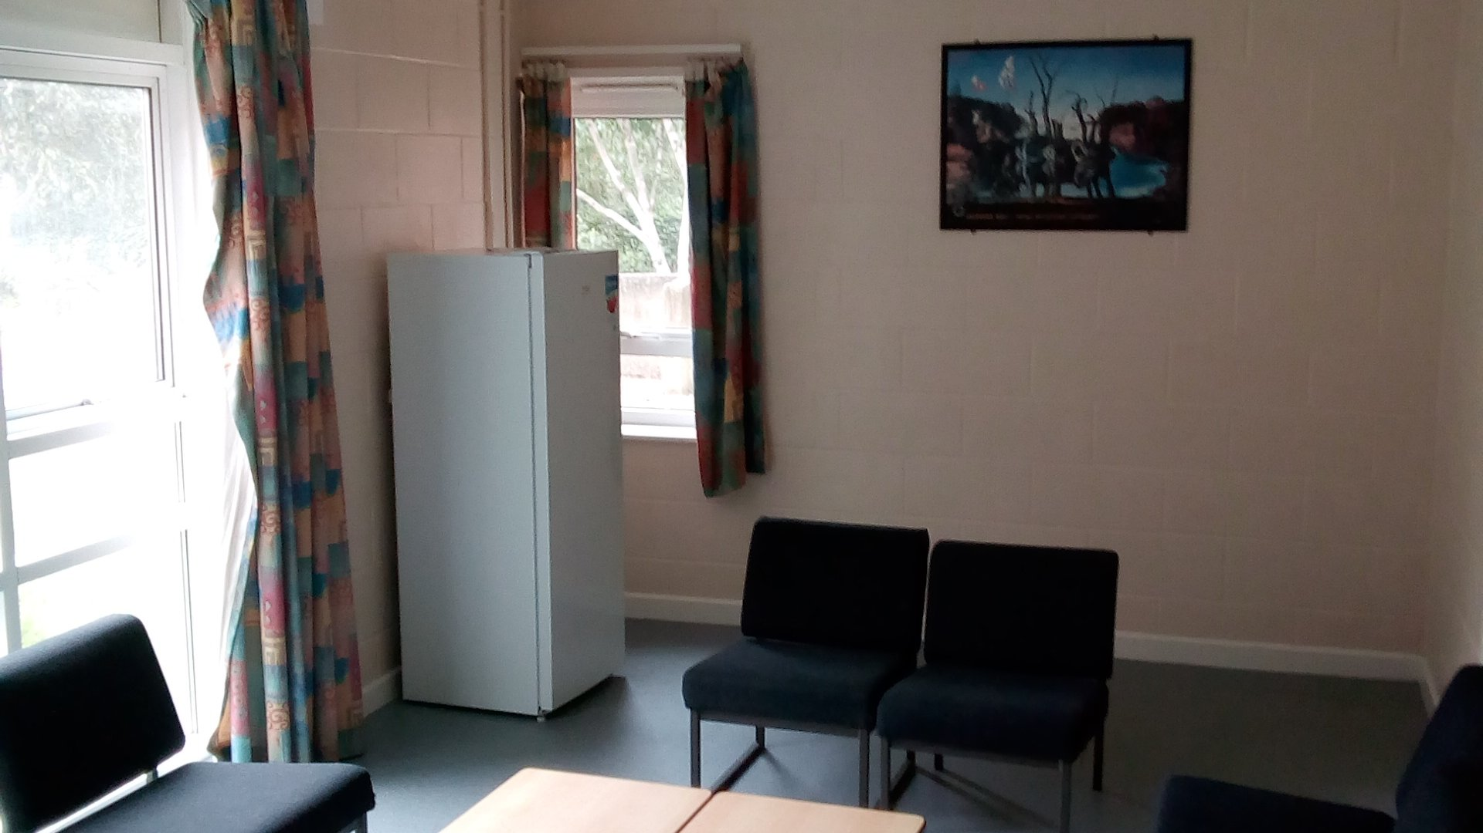

Lordship Road, Writtle, Chelmsford CM1 3RR, UK, from 11 to 17 age

Course intensity | 15
Accommodation | Campus
Room type | Single
Bathroom facilities | Shared
Meals | Breakfast, Lunch and Dinner
Excursions per week | 3
Weekday excursions | 2
Full day excursions | 5

Description

Why choose this program

Infrastructure

Sport infrastructure

Hobbies and clubs

What else included in the program price

Recommended arrival city

Лондон

Sample timetable
 | Morning | Afternoon | Evening
Day 1 | Arrivals - Check in | Orientation Tour | Welcome Night & Carousel Conversations
Day 2 | Lessons | Social Games and Sports on campus | Disco
Day 3 | Full Day Excursion to Cambridge (Punting on River Cam included) | Full Day Excursion to Cambridge (Punting on River Cam included) | Picture Hunt
Day 4 | Full Day Excursion to London (River Cruise along the Thames included) | Full Day Excursion to London (River Cruise along the Thames included) | Fancy Dress Costume Disco
Day 5 | Lessons | Lessons | Quiz night
Day 6 | Lessons | Half Day Walking Tour in Chelmsford | Movie night
Day 7 | Lessons | Lessons | Karaoke night
Day 8 | Full-Day Excursion to Canterbury (entry ticket to Canterbury Cathedral) | Full-Day Excursion to Canterbury (entry ticket to Canterbury Cathedral) | Full-Day Excursion to Canterbury
Day 9 | Full-Day Excursion to London | Full-Day Excursion to London | Full-Day Excursion to London
Day 10 | Lessons | Sports activities | Murder Mystery
Day 11 | Lessons | Lessons | Plus Has Got Talent
Day 12 | Lessons | Half-Day Excursion to Chelmsford | Knockout
Day 13 | Full day excursion to Hastings (entry to True Crimes Museum) | Full day excursion to Hastings (entry to True Crimes Museum) | Scavenger Hunt
Day 14 | Lessons | Lessons | Disco

For booking please go to www.travelclass.org

