Bayswater Education Bayswater College — language school in the UK

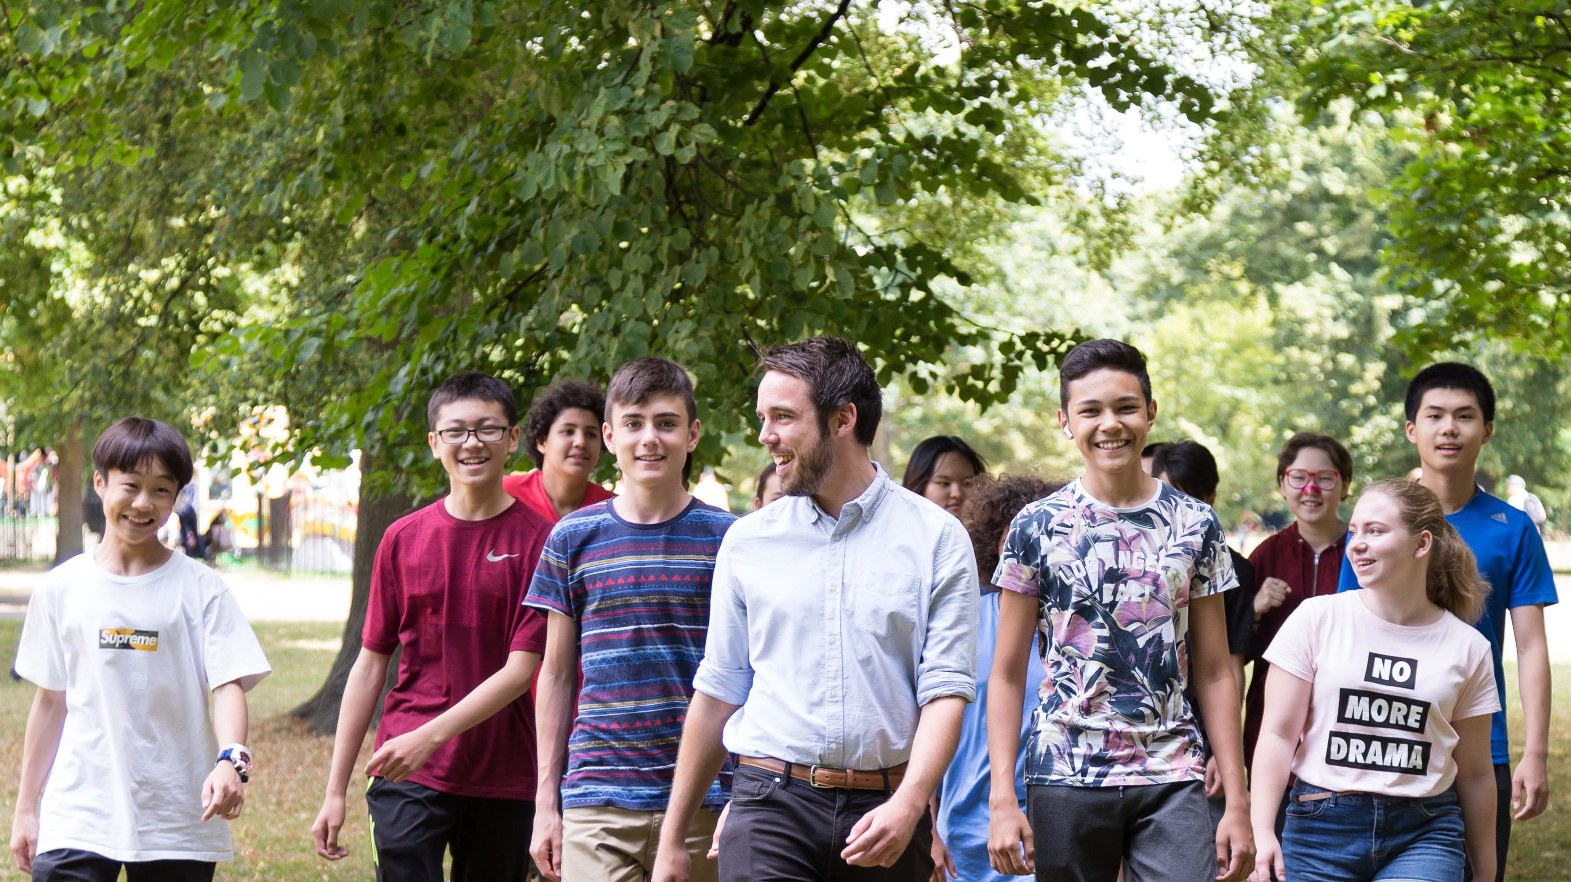

167 Queensway, London W2 4SB, UK, from 10 to 18 age

Course intensity | 15
Accommodation | Host family
Room type | Twin
Bathroom facilities | Shared
Meals | Breakfast, Lunch and Dinner
Excursions per week | 6
Weekday excursions | 5
Full day excursions | 1

Description

Why choose this program

Infrastructure

Sport infrastructure

Hobbies and clubs

What else included in the program price

Recommended arrival city

Лондон

Sample timetable
 | Morning | Afternoon | Evening
Day 1 |  | Arrival - private transfer to accommodation | Free time
Day 2 | Local area orientation tour | Lessons | River Thames Walking Tour
Day 3 | Westminster Walking Tour | Lessons | Trip to Oxford. Walking Tour & Entrance to Christ Church College 14:0018:00 River Thames Walking Tour South Kensington Museums– Science, Natural History, V&A
Day 4 | British Museum | Lessons | Greenwich Walking Tour
Day 5 | River Cruise Westminster- Tower Bridge | Lessons | Ride on the London Eye
Day 6 | Covent Garden, Leicester Square, Piccadilly & Oxford Street | Lessons | Camden Town
Day 7 | Full day trip to Windsor. Walking tour & Entrance to Windsor Castle | Full day trip to Windsor. Walking tour & Entrance to Windsor Castle | Full day trip to Windsor. Walking tour & Entrance to Windsor Castle

For booking please go to www.travelclass.org

