Ardmore London King's College — summer school in the UK

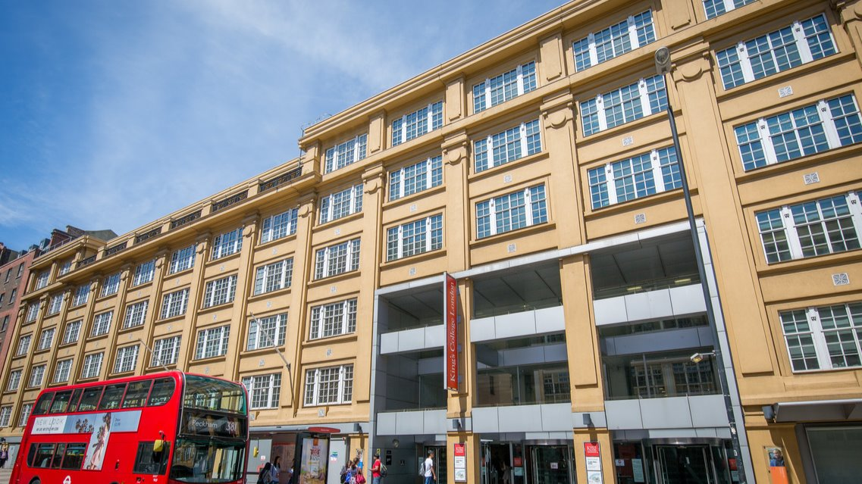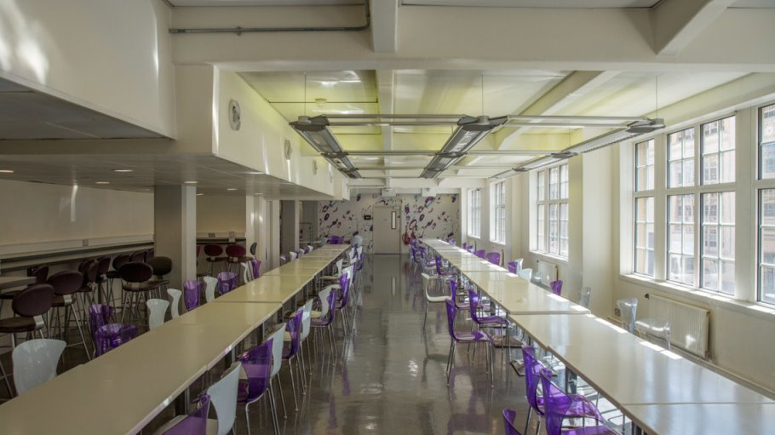

Strand Ln, London WC2R 2NA, UK, from 12 to 17 age

Course intensity | 15
Accommodation | Campus
Room type | Single
Bathroom facilities | En-suite
Meals | Breakfast, Lunch and Dinner
Excursions per week | 6
Weekday excursions | 5
Full day excursions | 1

Description

Why choose this program

Infrastructure

Sport infrastructure

Hobbies and clubs

What else included in the program price

Recommended arrival city

Лондон

Sample timetable
 | Morning | Afternoon | Evening
Day - | - | - | -

For booking please go to www.travelclass.org

