SCL International College North Acton — London language school, UK

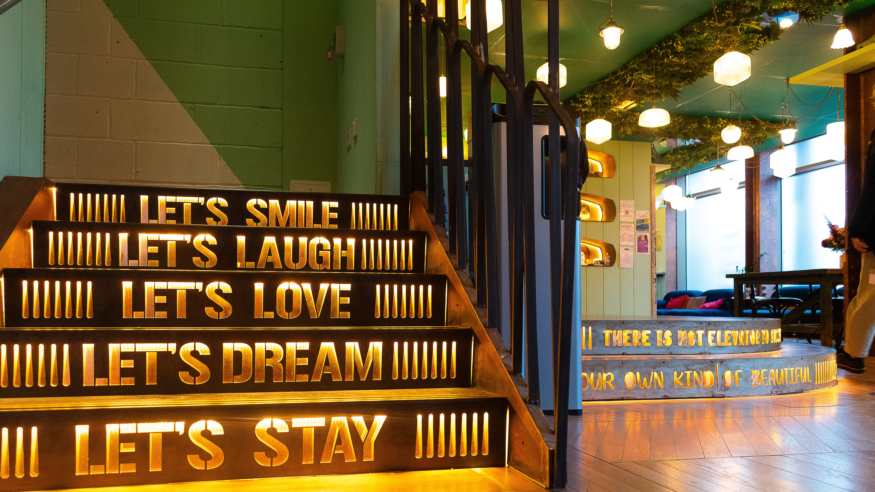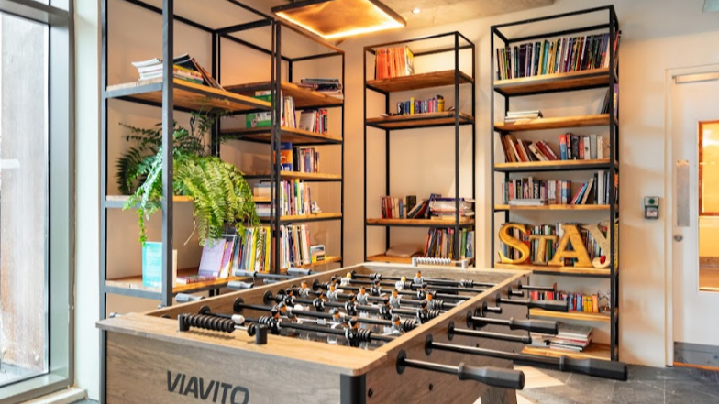

200 Western Avenue, London, W3 6FW, from 12 to 17 age

Course intensity
Accommodation | Campus
Room type | Triple
Bathroom facilities | En-suite
Meals | Breakfast, Lunch and Dinner
Excursions per week
Weekday excursions
Full day excursions

Description

Why choose this program

Infrastructure

Sport infrastructure

Hobbies and clubs

What else included in the program price

Recommended arrival city

Лондон

Sample timetable
 | Morning | Afternoon | Evening
Day 1

Day 2

Day 3

Day 4

Day 5

Day 6

Day 7

Day 8

Day 9

Day 10

Day 11

Day 12

Day 13

Day 14

For booking please go to www.travelclass.org

