Cobham Hall — summer school in the UK

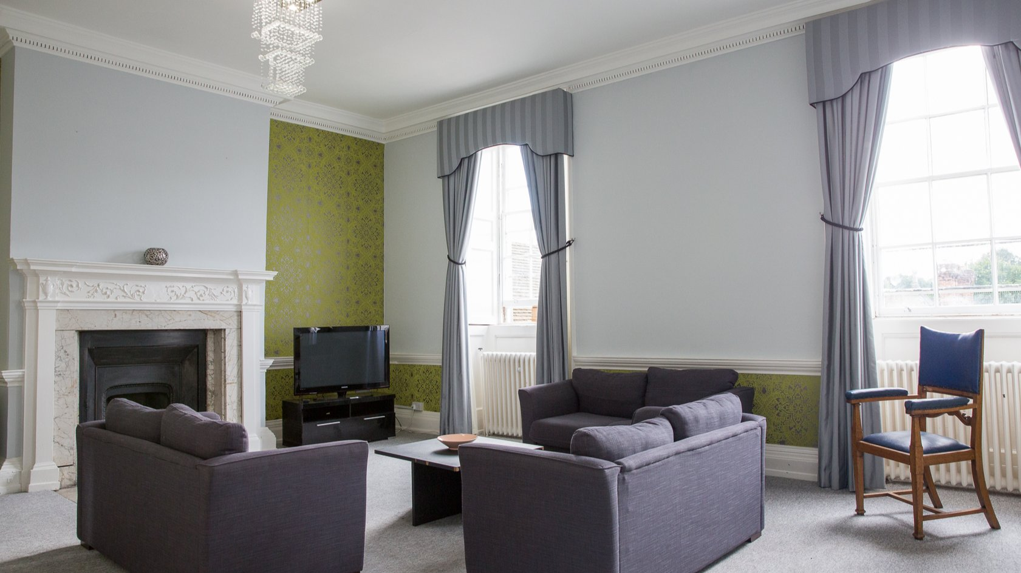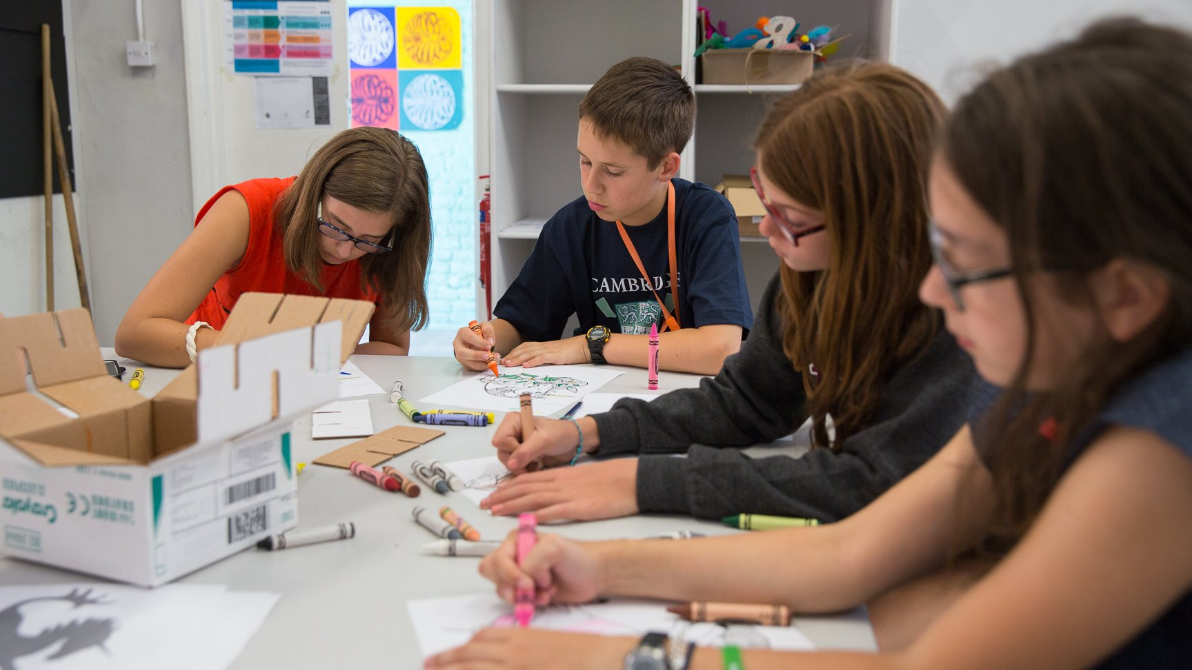

Cobham, Kent, UK, from 11 to 17 age

Course intensity | 15
Accommodation | Campus
Room type | Multi-bedded
Bathroom facilities | Shared
Meals | Breakfast, Lunch and Dinner
Excursions per week | 3
Weekday excursions | 2
Full day excursions | 1

Description

Why choose this program

Infrastructure

Sport infrastructure

Hobbies and clubs

What else included in the program price

Recommended arrival city

Лондон

Sample timetable
 | Morning | Afternoon | Evening
Day 1 | Lessons | Sports options Or Arts / cooking Options | Activity
Day 2 | Lessons | Activities / Excursion to Rochester | Activity
Day 3 | Lessons | Sports options Or Arts / cooking Options | Activity
Day 4 | Full day Excursion to London | Full day Excursion to London | Activity
Day 5 | Lessons | Samba Drumming Workshop | Themed Dance Party
Day 6 | Lessons | Historic Canterbury | Movie
Day 7 | Free Time | Free time | Activity

For booking please go to www.travelclass.org

