Ardmore LVS Ascot — summer school in the UK

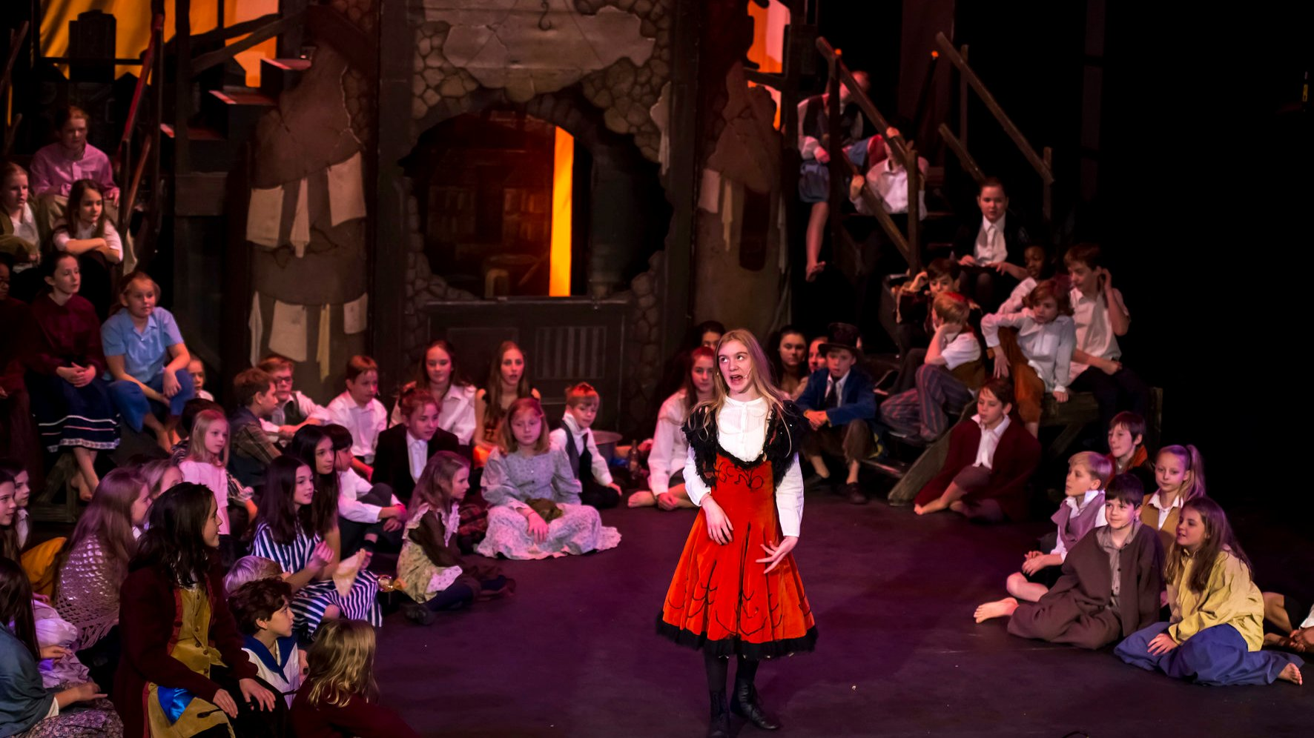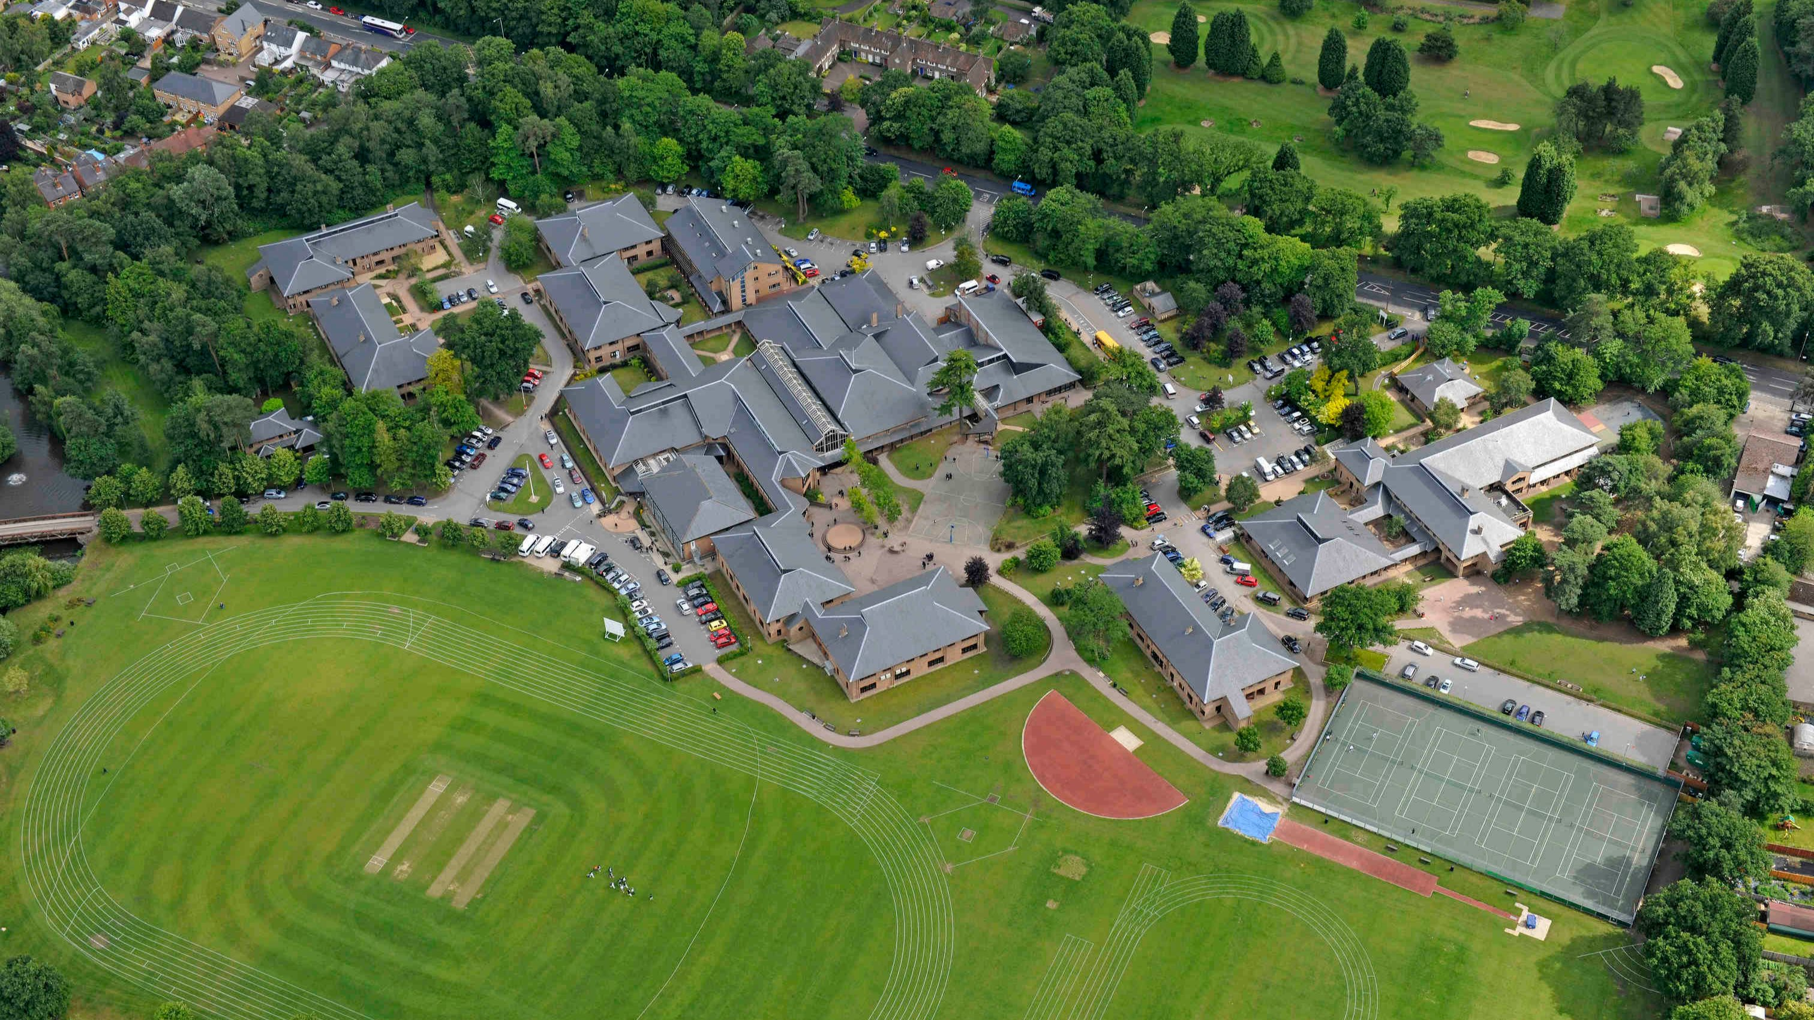

London Road, Winkfield Row, Ascot SL5 8DR, UK, from 9 to 17 age

Course intensity | 15
Accommodation | Campus
Room type | Multi-bedded
Bathroom facilities | Shared
Meals | Breakfast, Lunch and Dinner
Excursions per week | 2
Weekday excursions | 1
Full day excursions | 1

Description

Why choose this program

Infrastructure

Sport infrastructure

Hobbies and clubs

What else included in the program price

Recommended arrival city

Лондон

Sample timetable
 | Morning | Afternoon | Evening
Day 1 | Arrival | Arrival | Arrival
Day 2 | Lessons | Sports & Leisure Activities | Welcome Icebreaker Games
Day 3 | Lessons | Sports & Leisure Activities | Blind Date
Day 4 | Lessons | Half Day Excursion to Windsor Castle | Talent Show
Day 5 | Lessons | Sports & Leisure Activities | Casino night
Day 6 | Lessons | Sports & Leisure Activities | Disco
Day 7 | Full Day Excursion to London | Full Day Excursion to London | Sports tournament
Day 8 | Sports and Leisure Activities on Campus / Optional Extra Excursions | Sports and Leisure Activities on Campus / Optional Extra Excursions | Movie Night
Day 9 | Sports & Leisure Activities | Lessons | Capture the Flag
Day 10 | Sports & Leisure Activities | Lessons | Quiz
Day 11 | Half Day Excursion to Reading Town and Museum | Lessons | Karaoke
Day 12 | Sports & Leisure Activities | Lessons | Rounders
Day 13 | Sports & Leisure Activities | Lessons | Disco
Day 14 | Full Day Excursion to Oxford, Oxford Castle and Universities Walking Tour | Full Day Excursion to Oxford, Oxford Castle and Universities Walking Tour | Mini Olympics

For booking please go to www.travelclass.org

