Irish College of English Clongowes Wood College — summer school in Ireland

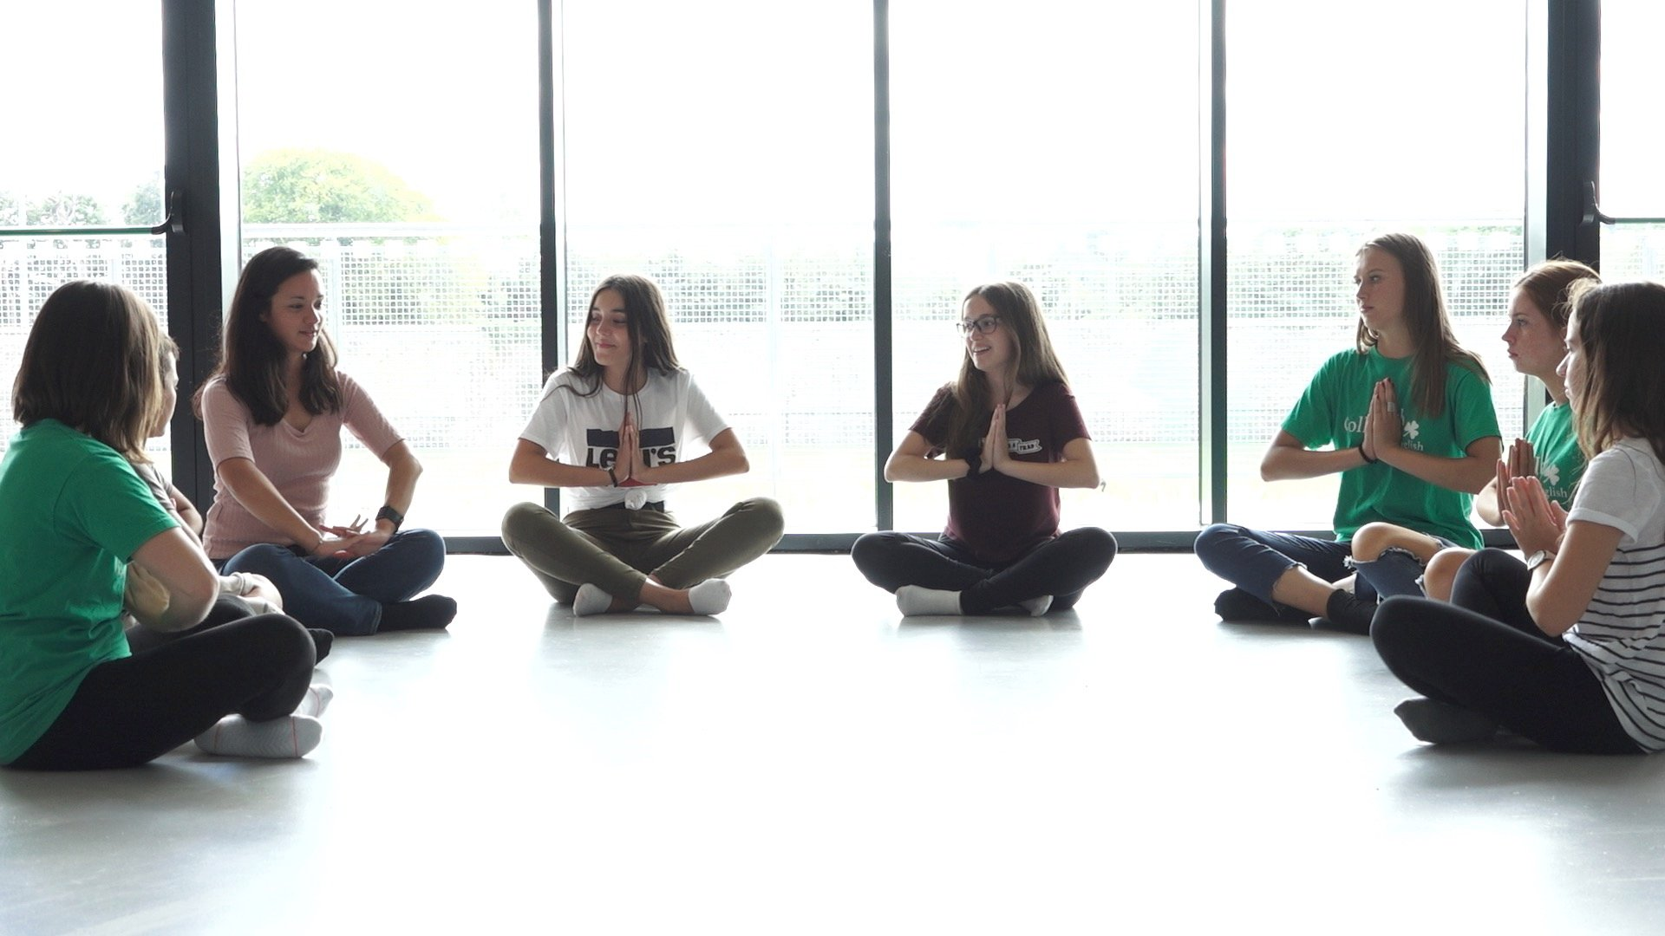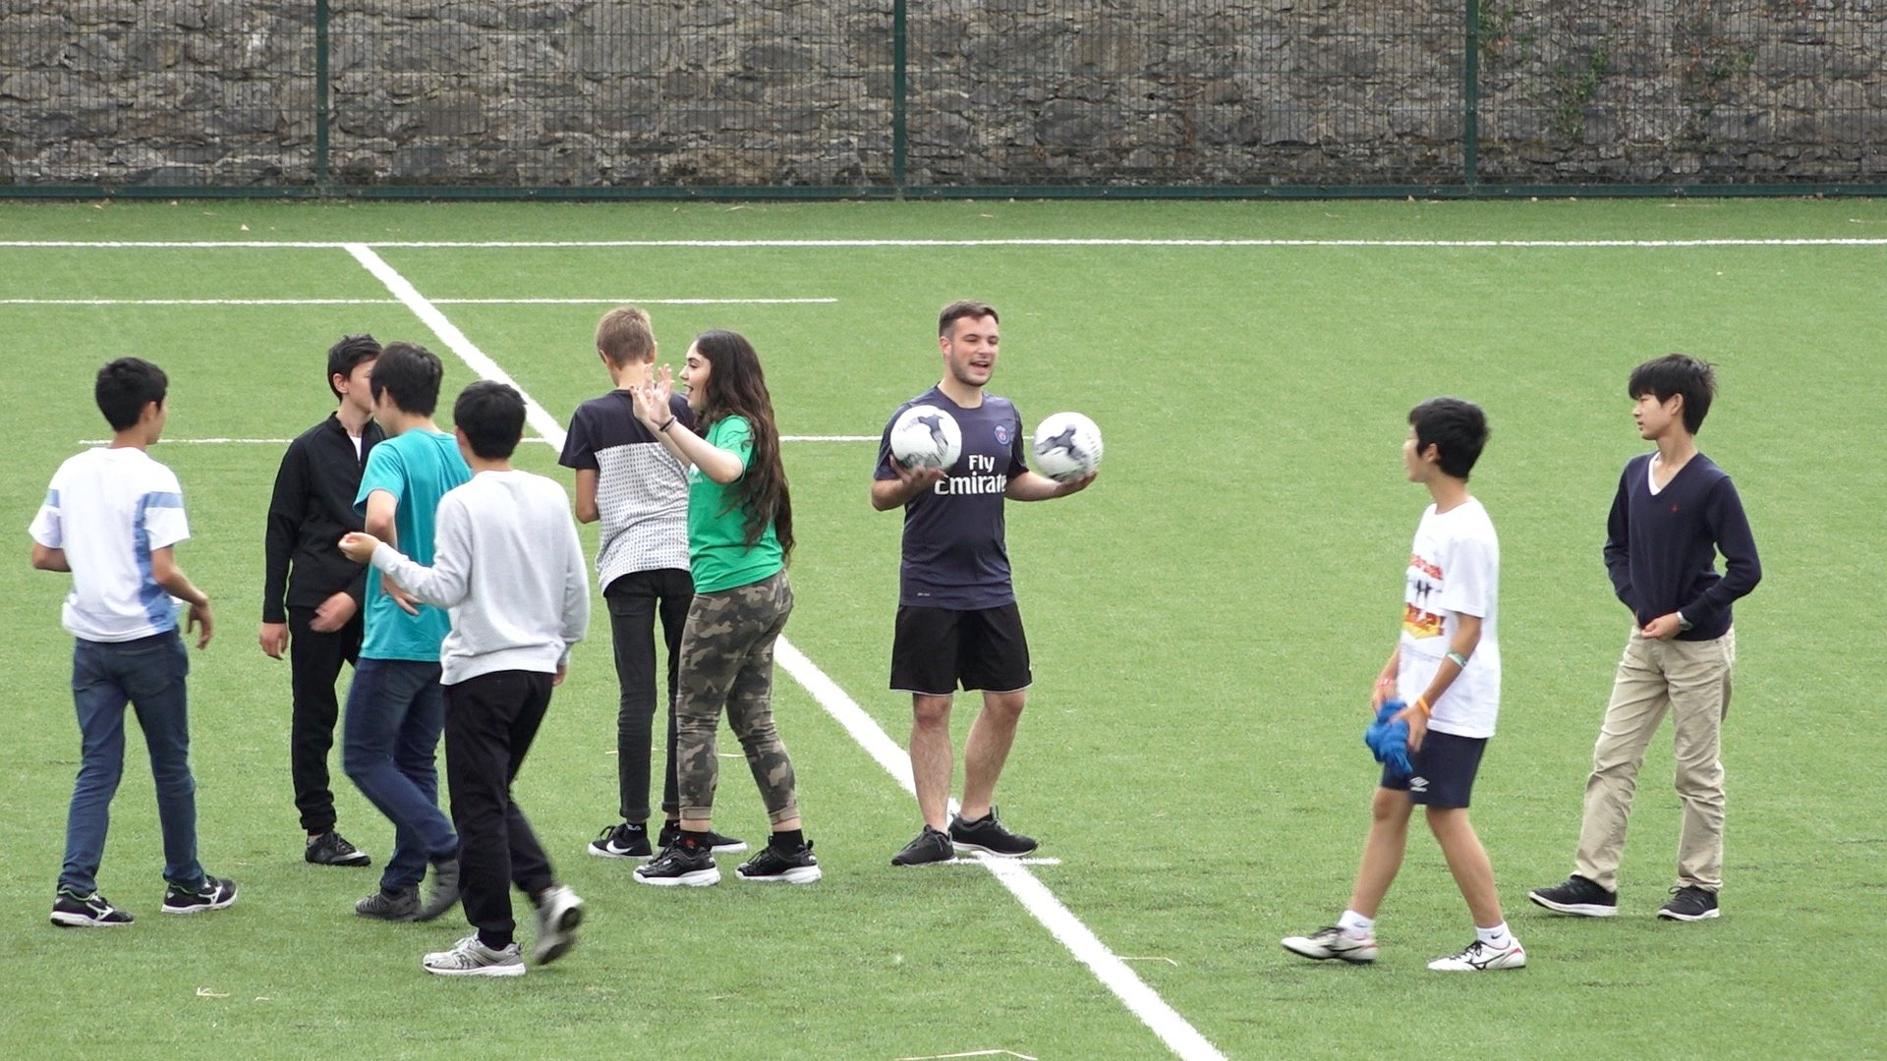

Clongowes Wood College, Castlebrown, Clane, County Kildare, Ireland, from 11 to 17 age

Course intensity | 15
Accommodation | Résidence
Room type | Twin
Bathroom facilities | Shared
Meals | Breakfast, Lunch and Dinner
Excursions per week | 4
Weekday excursions | 3
Full day excursions | 1

Description

Why choose this program

Infrastructure

Sport infrastructure

Hobbies and clubs

What else included in the program price

Recommended arrival city

Дублин

Sample timetable
 | Morning | Afternoon | Evening
Day 1 | English Classes | Dublin City Professional Walking Tour | Evening Elective Learn a Skill
Day 2 | English Classes | Sports on Site | Team Building
Day 3 | English Classes | Dinner and Shopping in Dublin City | Evening Elective Learn a Skill
Day 4 | English Classes | Swimming and Water Games | Movie Night
Day 5 | English Classes | Bowling off site | Evening Elective Learn a Skill
Day 6 | English Classes | Full Day Trip to Glenalough | Full Day Trip to Glenalough
Day 7 | Activity Relaxation Day on Site | Activity Relaxation Day on Site | Team Building

For booking please go to www.travelclass.org

