MLA Christ Church University — summer school in the UK

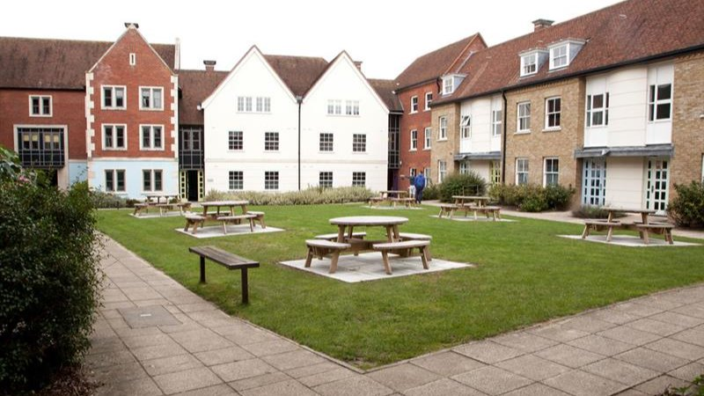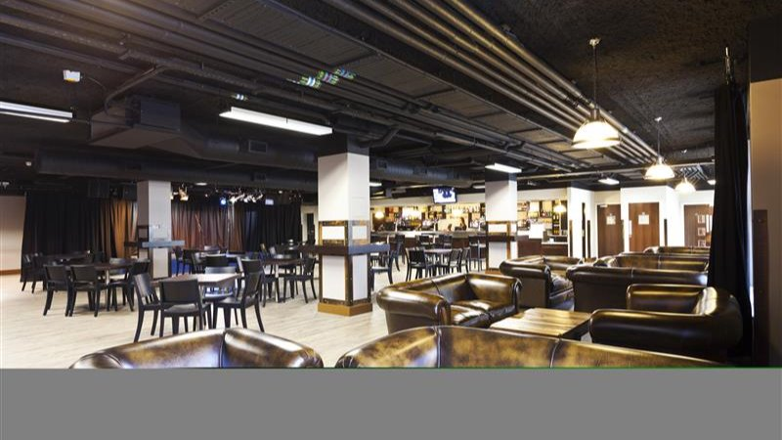

Canterbury Christ Church University - Johnson, North Holmes Road, Canterbury, UK, from 11 to 18 age

Course intensity | 15
Accommodation | Campus
Room type | Single
Bathroom facilities | En-suite
Meals | Breakfast, Lunch and Dinner
Excursions per week | 4
Weekday excursions | 3
Full day excursions | 1

Description

Why choose this program

Infrastructure

Sport infrastructure

Hobbies and clubs

What else included in the program price

Recommended arrival city

Лондон

Sample timetable
 | Morning | Afternoon | Evening
Day 1 | Arrival | Arrival | Movie - In & Welcome party
Day 2 | Orientation and testing | Walking Tour | Movie Night
Day 3 | Lessons | Winchester Cathedral | British disco
Day 4 | Lessons | Sport | Quiz Night
Day 5 | Lessons | Shopping at the Oracle | Karaoke
Day 6 | Lessons | Sport | Treasure hunt
Day 7 | London Walking Tour & Cruise on Thames | London Walking Tour & Cruise on Thames | Hard rock cafe
Day 8 | Half day Canterbury Tales | Lessons | Karaoke and chit chat
Day 9 | Sports & Leisure | Lessons | British Disco
Day 10 | Half day Dover and The White Cliffs | Lessons | Amazing MLA Race
Day 11 | Sports & Leisure | Lessons | The Canterbury Tales Experience
Day 12 | Half day Canterbury shopping | Lessons | MLA's Got Talent
Day 13 | Full day Cambridge | Full day Cambridge | Disco
Day 14 | Graduation ceremony | Departure

For booking please go to www.travelclass.org

