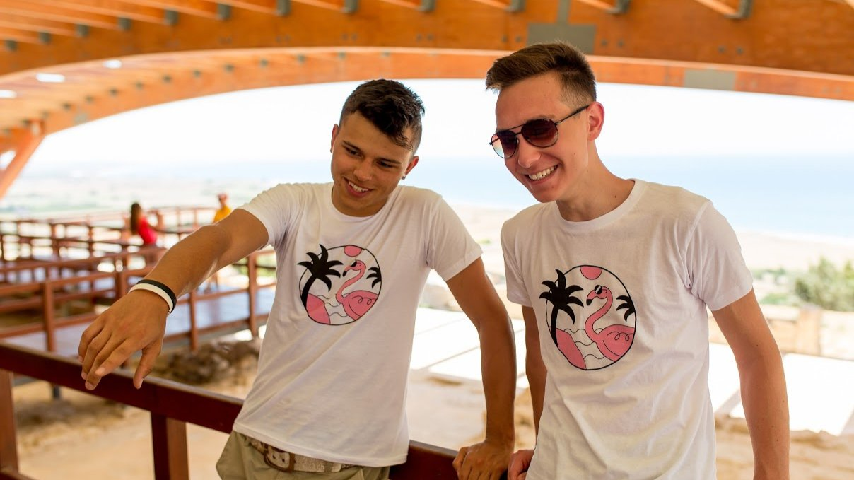

Bayswater English in Cyprus UCLan — summer school in Cyprus
UCLan Cyprus, University Avenue, Пила, from 7 to 17 age

Course intensity | 15
Accommodation | Universidad
Room type | Doble
Bathroom facilities | En-suite
Meals | Desayuno, comida y cena
Excursions per week | 3
Weekday excursions | 2
Full day excursions | 1

Description

Why choose this program

Infrastructure

Sport infrastructure

Hobbies and clubs

What else included in the program price

Recommended arrival city

Ларнака

Sample timetable
 | Morning | Afternoon | Evening
Day 1 | Arrival
Day 2 | English Lessons | Beach or pool | Dance
Day 3 | English Lessons | Afternoon excursion: Nicosia Mall | Games Night
Day 4 | English Lessons | Beach or pool | Karaoke
Day 5 | English Lessons | Beach or pool | Disco and karaoke night
Day 6 | Lessons | Beach or pool | Movie night
Day 7 | Full day excursion: Kalidonia waterfalls and mountain villages | Full day excursion: Kalidonia waterfalls and mountain villages | Full day excursion: Kalidonia waterfalls and mountain villages
Day 8 | Optional excursion | Optional excursion | Optional excursion
Day 9 | Lessons | Beach or pool | Dance
Day 10 | Lessons | Beach or pool | Games
Day 11 | Lessons | Kamara to Koraka | Murder Mystery
Day 12 | Lessons | Beach or pool | Robot Wars
Day 13 | Lessons | Beach or pool | Disco
Day 14 | Full day excursion: Ayia Napa Boat Trip | Full day excursion: Ayia Napa Boat Trip | Full day excursion: Ayia Napa Boat Trip

Price: 739,23 €

Dates: 2021-06-27 - 2021-07-04

Group leader: Mordovskaia Iana Valerevna, 79220848374, mordovskaya74@mail.ru

