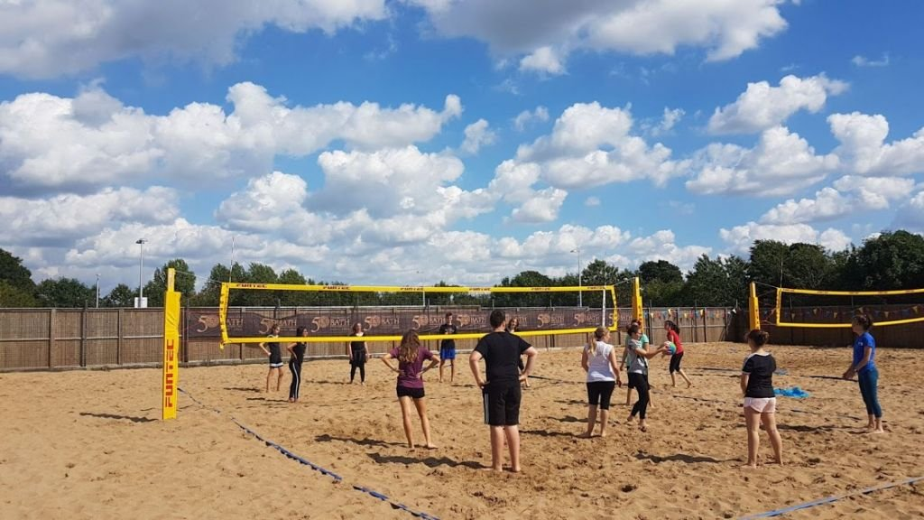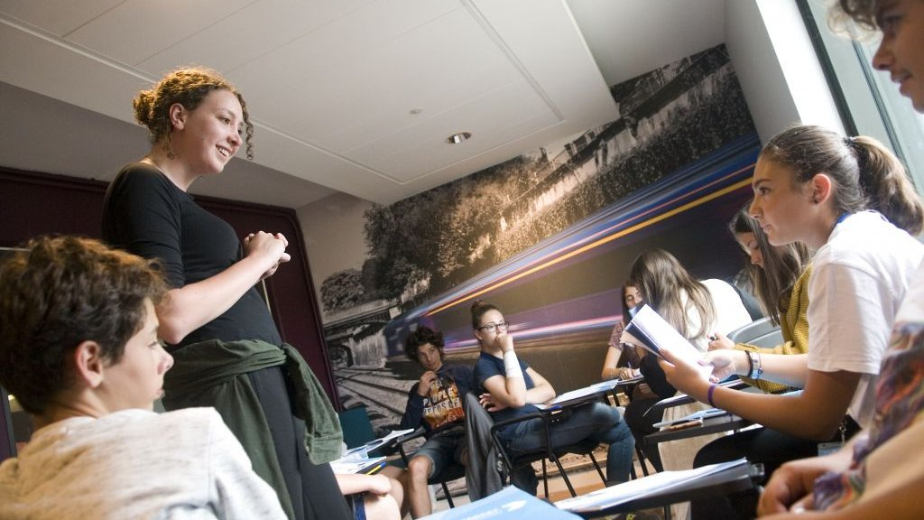

Target University of Bath: escola d&#039;estiu al Regne Unit
Claverton Down Road, Claverton Down, Bath BA2 7AY, UK, from 10 to 19 age

Course intensity | 15
Accommodation | Campus
Room type | Single
Bathroom facilities | En-suite
Meals | Breakfast, Lunch and Dinner
Excursions per week | 3
Weekday excursions | 1
Full day excursions | 2

Description

Why choose this program

Infrastructure

Sport infrastructure

Hobbies and clubs

What else included in the program price

Recommended arrival city

Лондон

Sample timetable
 | Morning | Afternoon | Evening
Day 1 | Test & Induction Lesson | Bath Walking Tour and Orientation | Evening activity
Day 2 | Lessons | Sports, activities and workshops | Evening activity
Day 3 | Lessons | Half-day excursion to Stonehenge | Evening activity
Day 4 | Lessons | Sports, activities and workshops | Evening activity
Day 5 | Lessons | Local visit to Bath & entrance to roman Bathst | Evening activity
Day 6 | Full-day excursion to Bristol or Cardiff & Castle | Full-day excursion to Bristol or Cardiff & Castle | Evening activity
Day 7 | Full-day excursion to London & late return | Full-day excursion to London & late return | Evening activity

Price: €2.661,59

Dates: 2019-07-14 - 2019-07-28

Group leader: Биркенгоф Дарья Дмитриевна, 89651585791, birkengoff@mail.ru

