ALPADIA Montreux — language school in Switzerland

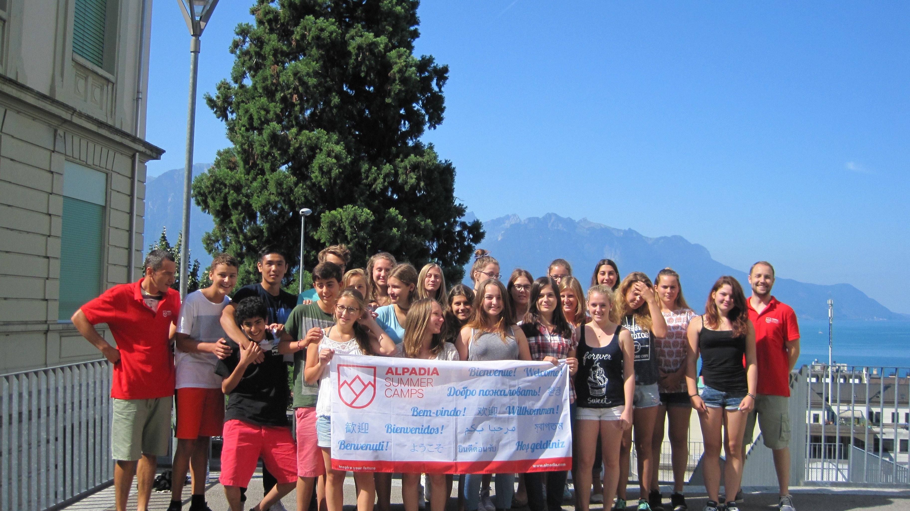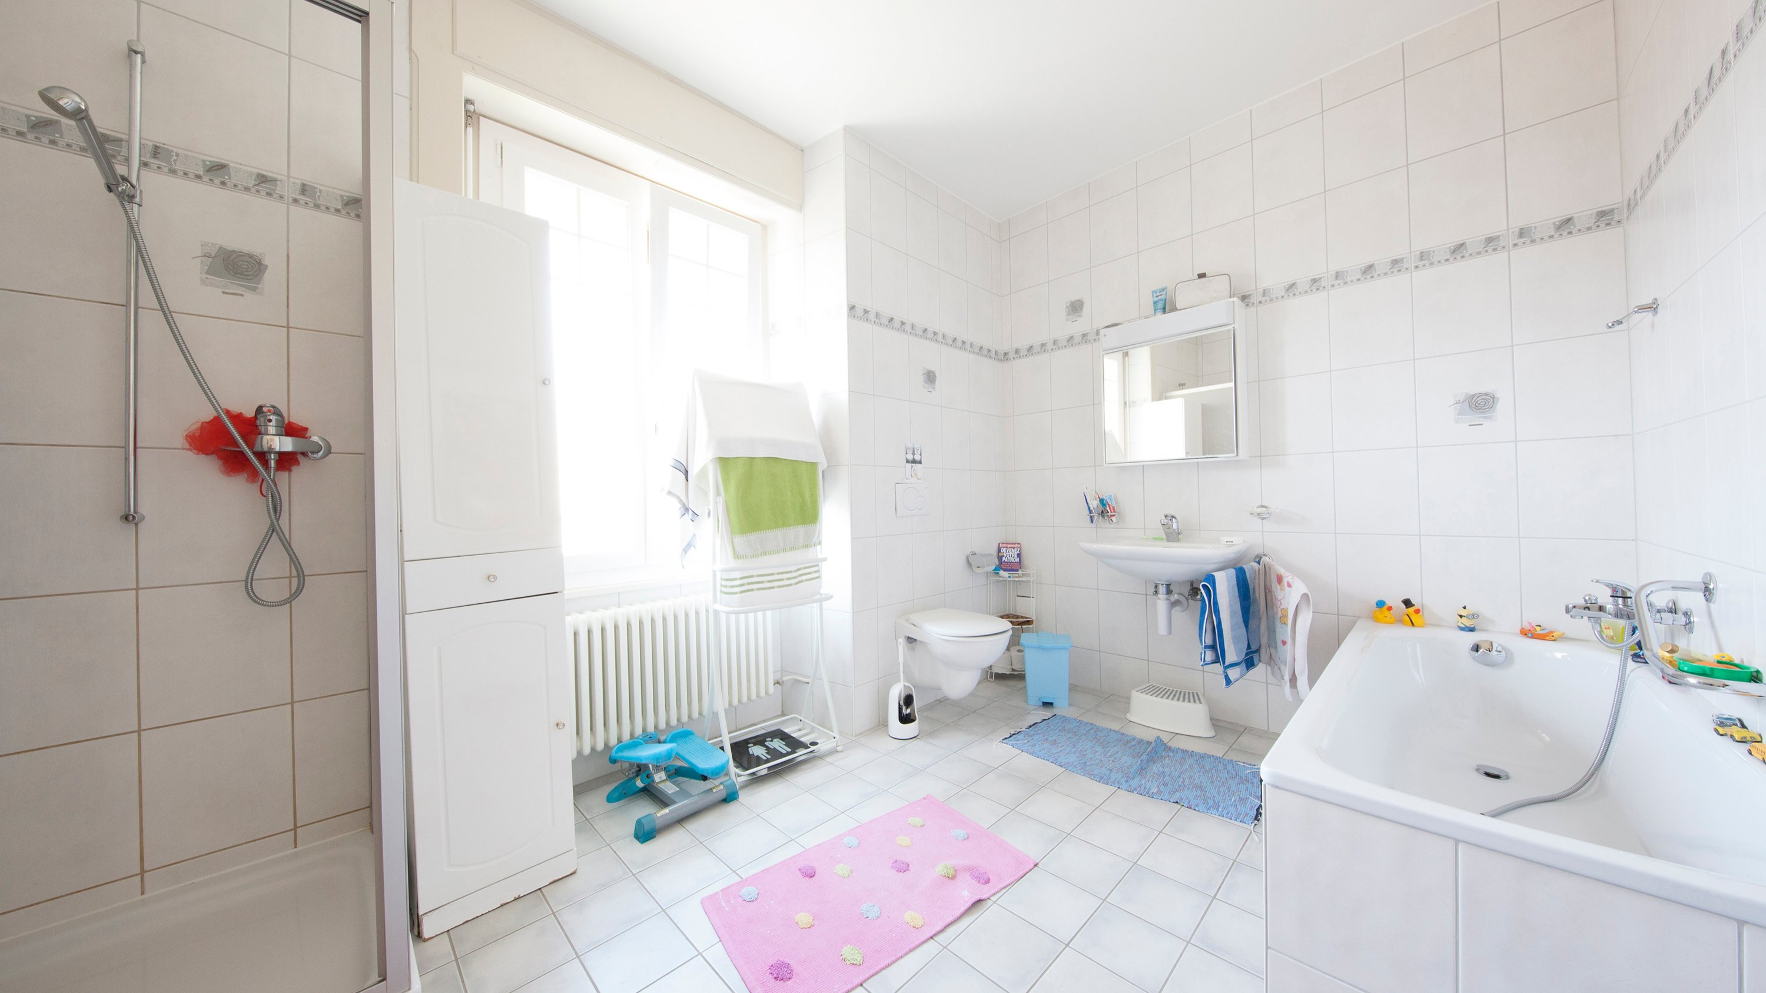

Rue de la Gare 33, 1820 Montreux, Switzerland, from 13 to 17 age

Course intensity | 15
Accommodation | Host family
Room type | Single
Bathroom facilities | Shared
Meals | Breakfast + Dinner
Excursions per week | 3
Weekday excursions | 2
Full day excursions | 1

Description

Why choose this program

Infrastructure

Sport infrastructure

Hobbies and clubs

What else included in the program price

Recommended arrival city

Женева

Sample timetable
 | Morning | Afternoon | Evening
Day 1 | Arrival | Arrival | Evening with host-family
Day 2 | Lessons | Sports activities | Evening with host-family
Day 3 | Lessons | Château de Chillon | Evening with host-family
Day 4 | Lessons | Sports activities | Evening with host-family
Day 5 | Lessons | Lake Geneva | Evening with host-family
Day 6 | Lessons | Sports activities | Evening with host-family
Day 7 | Jazz music/Comedy festival | Jazz music/Comedy festival | Evening with host-family

For booking please go to www.travelclass.org

