friLingue Schwarzsee — summer language school in Switzerland

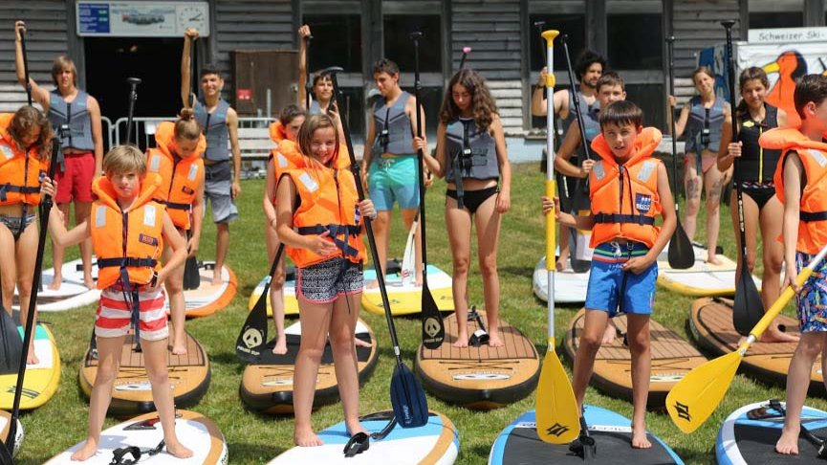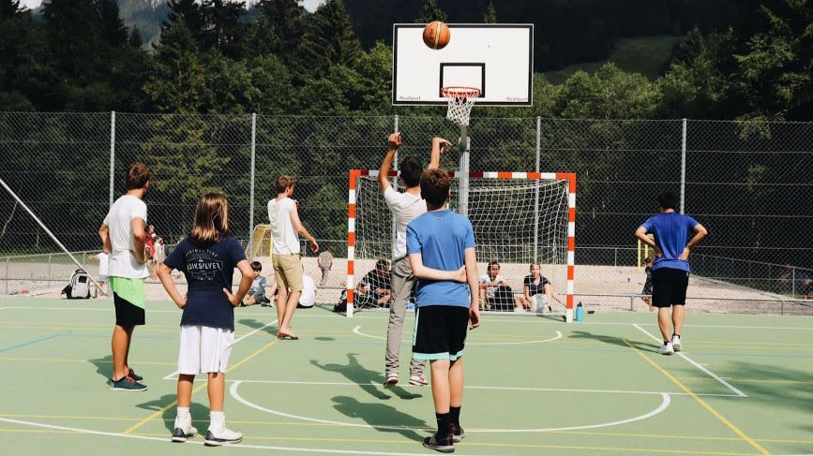

Schwarzsee, Switzerland, from 8 to 17 age

Course intensity | 15
Accommodation | Campus
Room type | Quadraple
Bathroom facilities | Shared
Meals | Breakfast, Lunch and Dinner
Excursions per week | 3
Weekday excursions | 2
Full day excursions | 1

Description

Why choose this program

Infrastructure

Sport infrastructure

Hobbies and clubs

What else included in the program price

Recommended arrival city

Женева

Sample timetable
 | Morning | Afternoon | Evening
Day 1 | Free | Arrivals | Welcome meeting and oral test
Day 2 | Class | Workshops | Sports tournament
Day 3 | Class | Hiking ( excursion ) | Free
Day 4 | Class | Workshops | Karaoke
Day 5 | Class | Brecca Valley | Campfire
Day 6 | Class | Free | Disco
Day 7 | Excursion to Fribourg | Excursion to Fribourg | Free

For booking please go to www.travelclass.org

