Merchiston Castle School - escola d'estiu a Escòcia

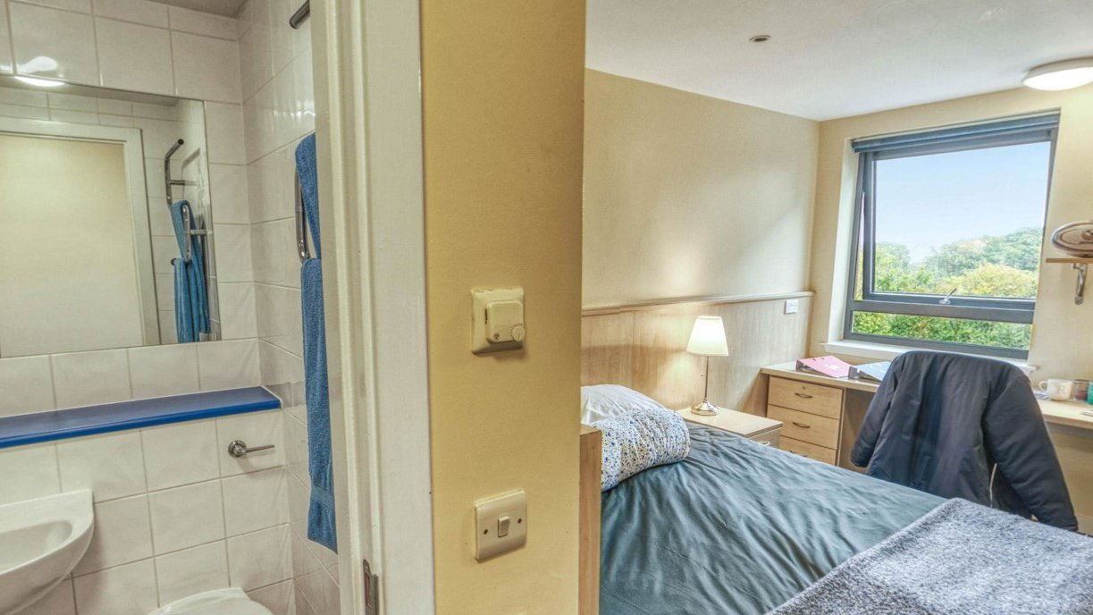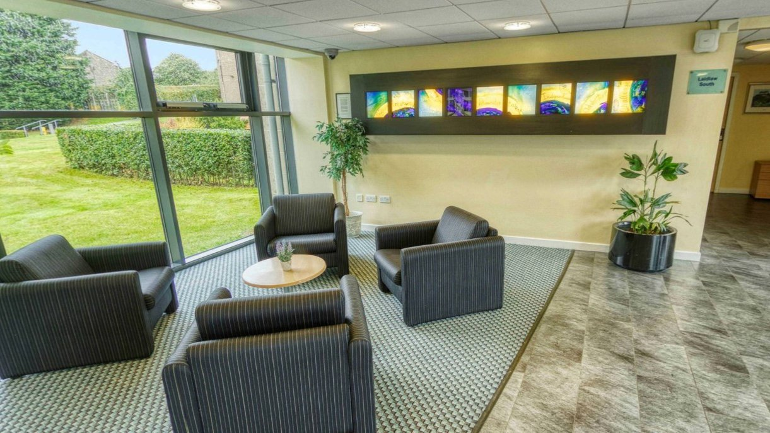

Merchiston Castle School, Edinburgh, Colinton Road, Edinburgh, UK, from 11 to 18 age

Course intensity
Accommodation | Campus
Room type | Twin
Bathroom facilities | En-suite
Meals | Breakfast, Lunch and Dinner
Excursions per week | 2
Weekday excursions | 2
Full day excursions

Description

Why choose this program

Infrastructure

Sport infrastructure

Hobbies and clubs

What else included in the program price

Recommended arrival city

Эдинбург

Sample timetable
 | Morning | Afternoon | Evening
Day 1 | Lessons | EDINBURGH  National Museum of Scotland  Greyfriars Kirkyard | Lip Sync Batle
Day 2 | Lessons | Badminton Rounders / ConversaƟon Club | Quiz
Day 3 | Lessons | EDINBURGH  Arthur's Seat  University of Edinburgh  Walking Tour | Murder Mystery
Day 4 | Lessons | Zumba  Football  Conversation Club | Music Bingo
Day 5 | Lessons | EDINBURGH  Edinburgh Castle | Ceilidh
Day 6 | STIRLING & LOCH  KATRINE  Loch Katrine Cruise  Stirling Town | STIRLING & LOCH  KATRINE  Loch Katrine Cruise  Stirling Town | Trashion Show
Day 7 | OPTIONAL DAY | OPTIONAL DAY | OPTIONAL DAY

For booking please go to www.travelclass.org

