IP Bournemouth - escola d'idiomes al Regne Unit

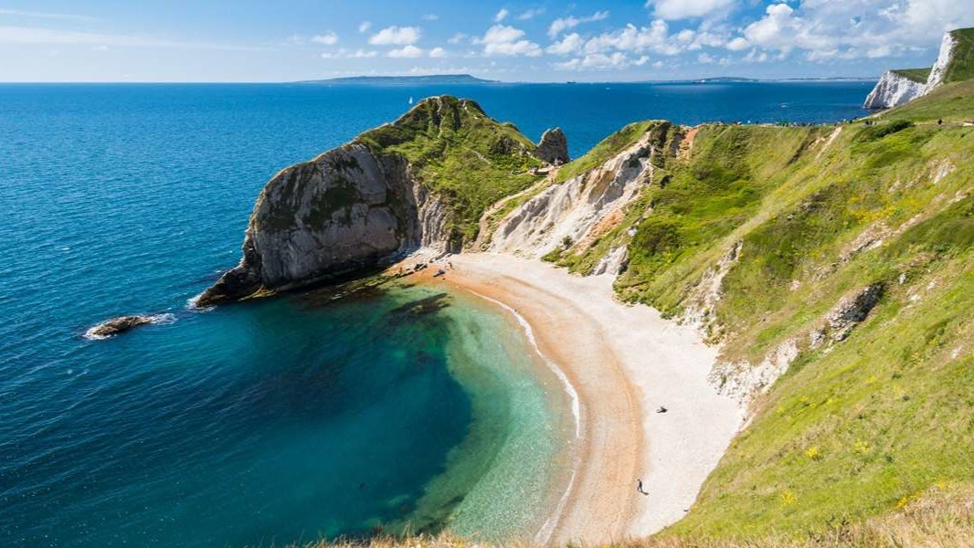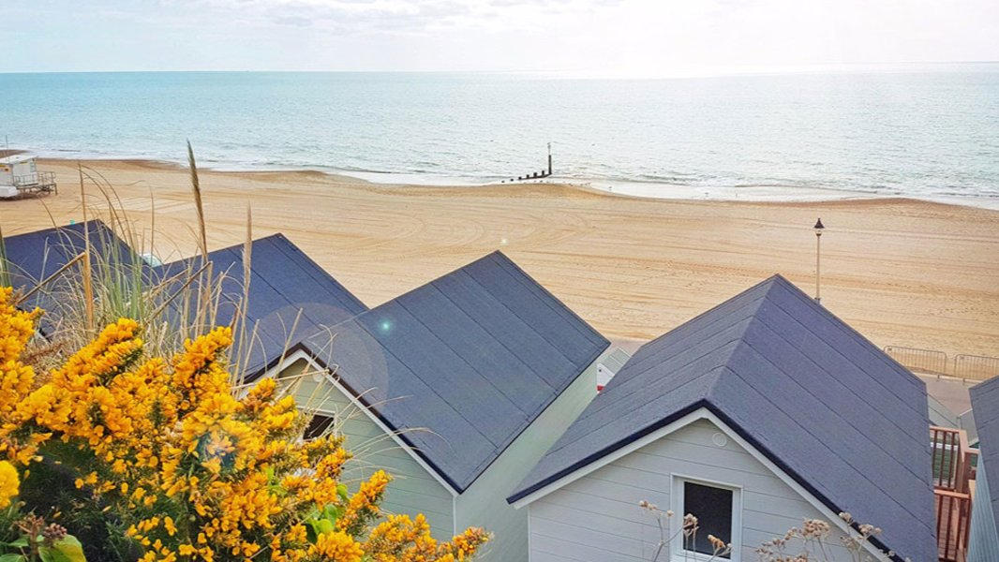

Europa School of English, Knole Road, Bournemouth, UK, from 11 to 17 age

Course intensity | 15
Accommodation | Host family
Room type | Twin
Bathroom facilities | Shared
Meals | Breakfast, Lunch and Dinner
Excursions per week | 1
Weekday excursions | 1
Full day excursions

Description

Why choose this program

Infrastructure

Sport infrastructure

Hobbies and clubs

What else included in the program price

Recommended arrival city

Лондон

Sample timetable
 | Morning | Afternoon | Evening
Day 1 | Arrival | Arrival | Arrival Party
Day 2 | Lessons | Orientation tour and
Day 3 | Lessons | Excursions to Bournemouth
Day 4 | Lessons | indoor or outdoor activity
Day 5 | Lessons | Excursions to Bournemouth | Movie night
Day 6 | Lessons | Cream Tea & Graduation | Disco
Day 7 | Breakfast | Departure

For booking please go to www.travelclass.org

