Chaucer College: escola d'anglès al Regne Unit

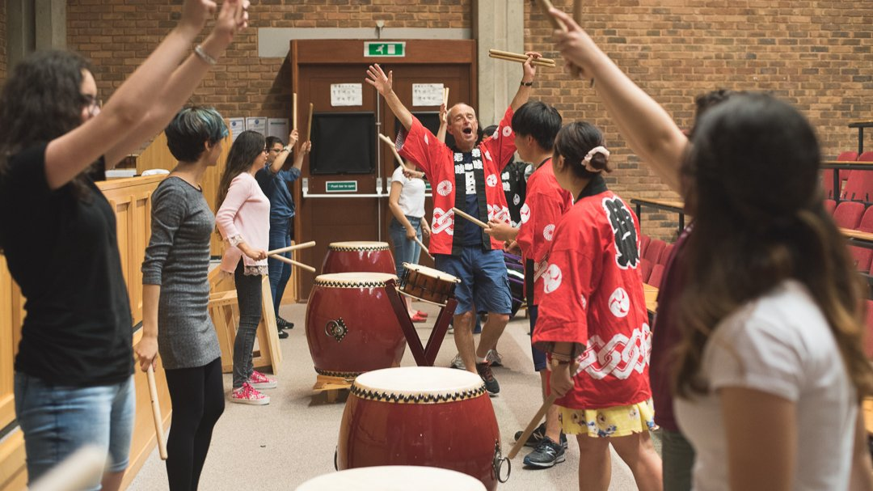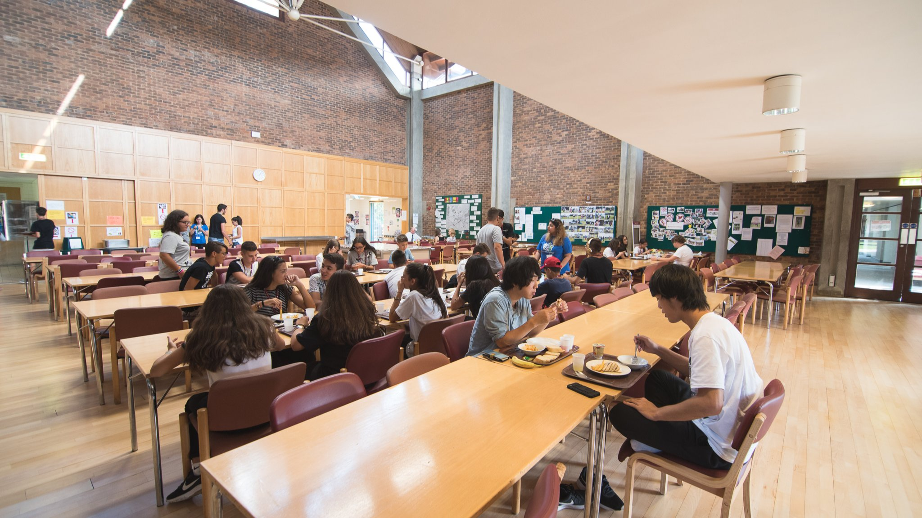

Canterbury CT2 7LJ, UK, from 10 to 17 age

Course intensity | 15
Accommodation | Residence
Room type | Twin
Bathroom facilities | Shared
Meals | Breakfast, Lunch and Dinner
Excursions per week | 2
Weekday excursions | 1
Full day excursions | 1

Description

Why choose this program

Infrastructure

Sport infrastructure

Hobbies and clubs

What else included in the program price

Recommended arrival city

Лондон

Sample timetable
 | Morning | Afternoon | Evening
Day 1 | Arrival | Local Tour | On-site activities
Day 2 | Lesson | City tour | Disco
Day 3 | Lesson | Free time | On-site activities
Day 4 | Lesson | Free time | Activity
Day 5 | Excursion to London | Excursion to London | Activity
Day 6 | Breakfast | Departure
Day 7

For booking please go to www.travelclass.org

