Seleccioneu Anglès - Culford

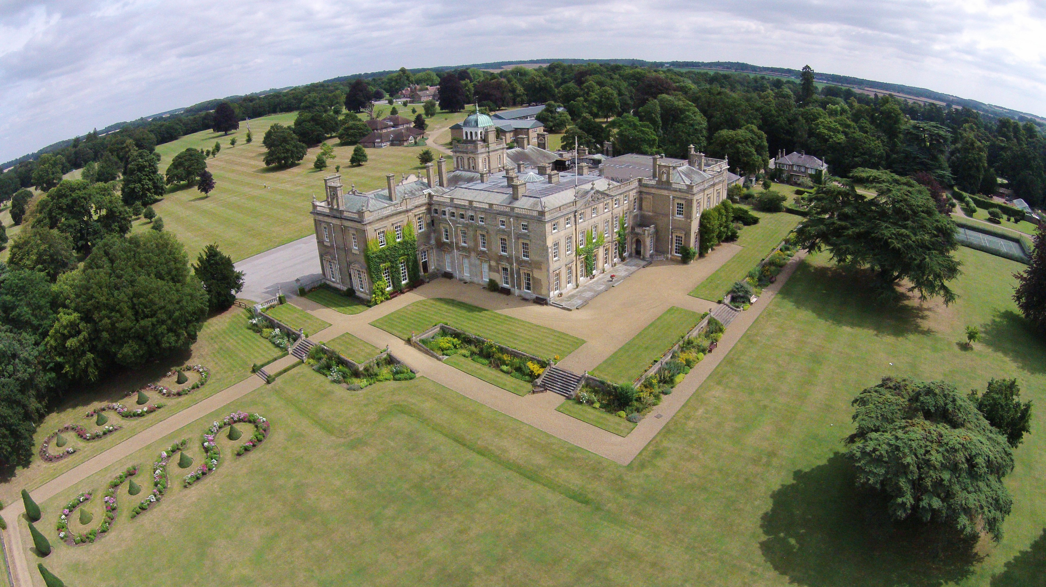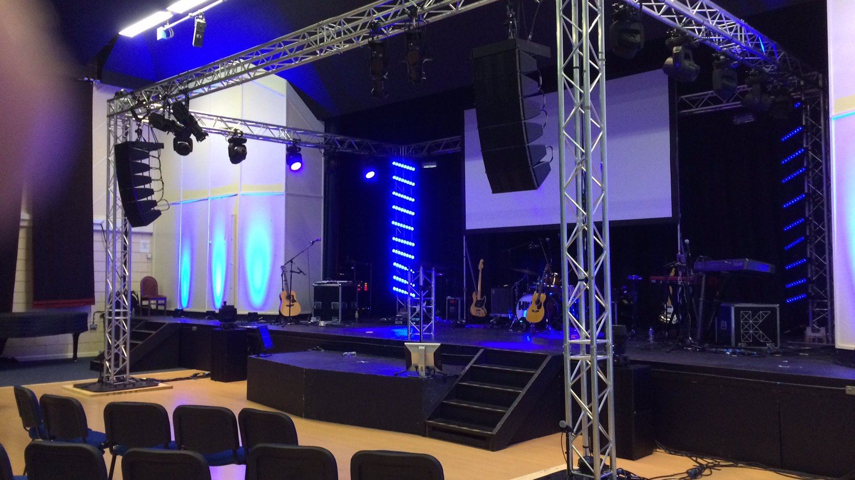

Culford School, Culford, Bury Saint Edmunds, UK, from 10 to 16 age

Course intensity | 20
Accommodation | Campus
Room type | Multi-bedded
Bathroom facilities | Shared
Meals | Breakfast, Lunch and Dinner
Excursions per week | 2
Weekday excursions
Full day excursions

Description

Why choose this program

Infrastructure

Sport infrastructure

Hobbies and clubs

What else included in the program price

Recommended arrival city

Лондон

Sample timetable
 | Morning | Afternoon | Evening
Day 1 | Arrivals
Day 2 | English Placement Test and English Lessons | Mini-Olympics | Welcome Party
Day 3 | English Lessons | Half-Day Trip to Bury St Edmunds | Swimming or Quiz Night
Day 4 | English Lessons | Water Games or Egg Escape | T-Shirt Designing or Volleyball
Day 5 | Full-Day Trip to Cambridge | Activities in Cambridge include: Chauffeur Punting on the River Cam, Walking Tour of Cambridge, and free time for souvenir shopping | Free Time
Day 6 | English Lessons | Football or Fashion Show | Casino Night and Summer Fair
Day 7 | English Lessons | Sculpture Making or Biscuit Decorating | British Food Experience
Day 8 | Full-Day Trip to London | Activities in London include:  - Walking Tour through Westminster to London Eye, Big Ben, Houses of Parliament, Westminster Abbey, Buckingham Palace and Trafalgar Square  - Free time on Oxford Street for Souvenir shopping | Free time
Day 9 | English Lessons | Capture the Flag or Tote-Bag Designing | Film Night
Day 10 | English Lessons | Tennis or Spaghetti Towers | Disco Night
Day 11 | English Lessons | Rugby or DIY Rockets | Dodgeball
Day 12 | English Lessons | Swimming | Big Night In
Day 13 | English Lessons | Select's Got Talent - Talent Show | Farewell Party
Day 14 | Departures

For booking please go to www.travelclass.org

