MILTON KEYNES

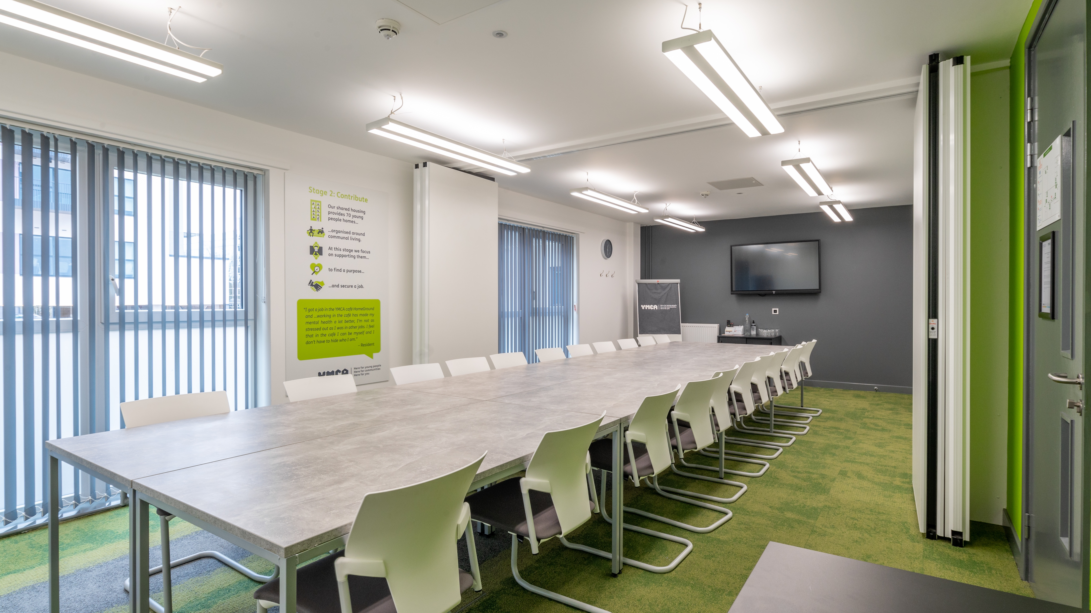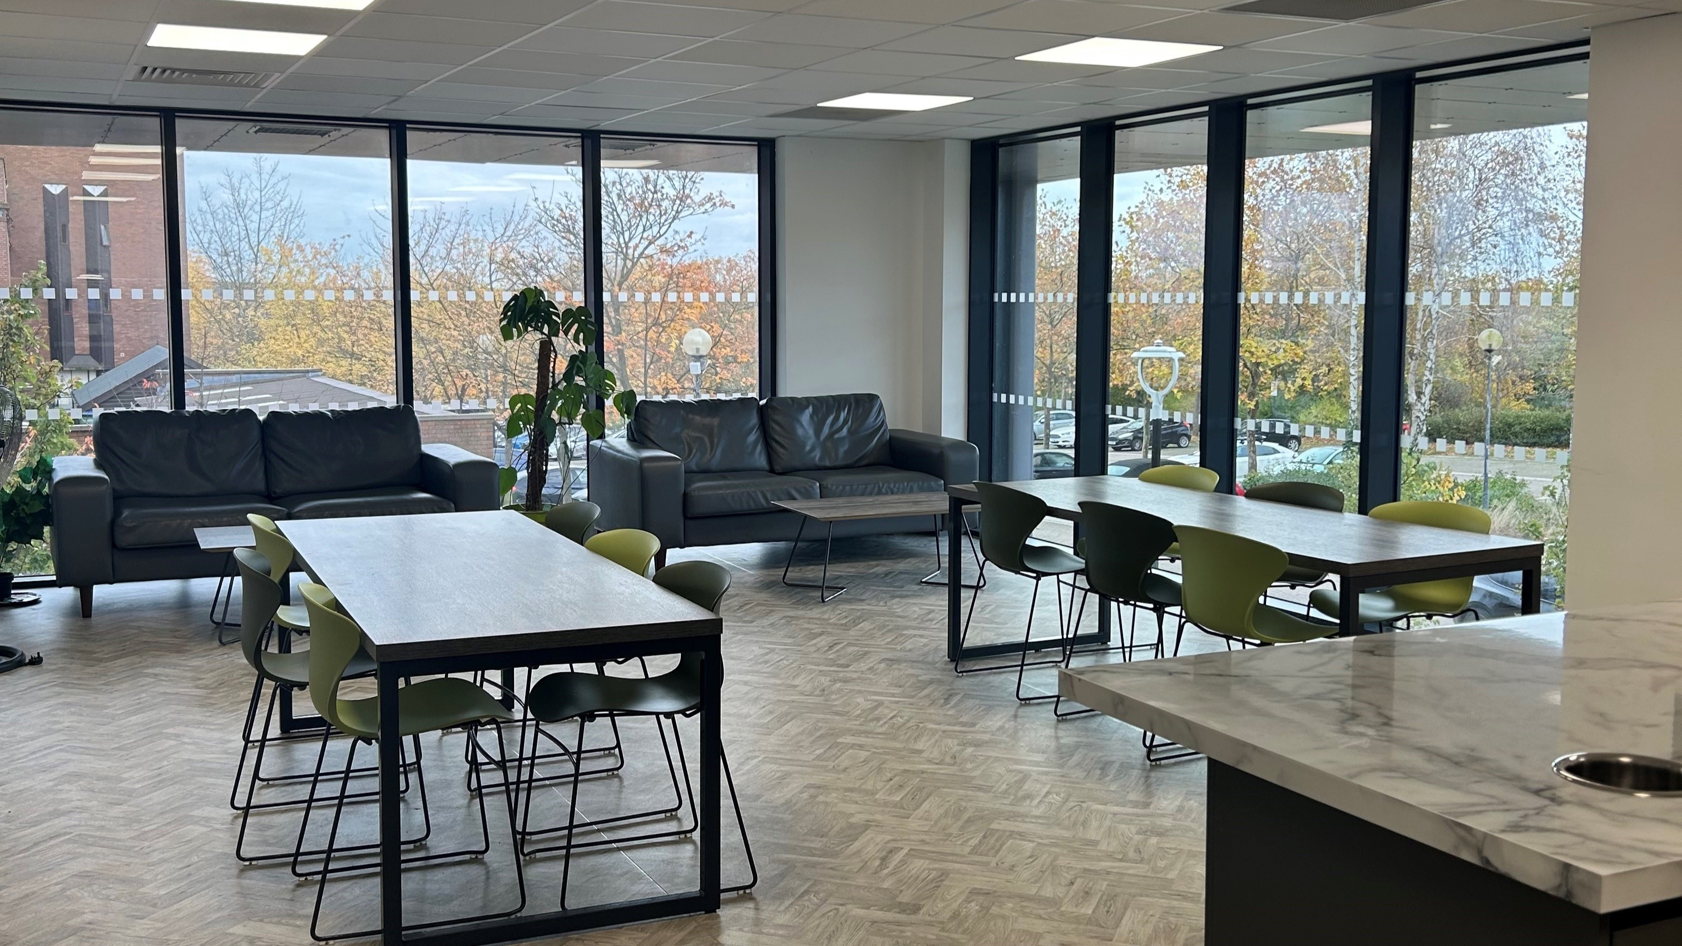

Johnston Place, Oldbrook, Milton Keynes MK6 2JY, UK, from 14 to 17 age

Course intensity | 720
Accommodation | Host family
Room type | Single
Bathroom facilities | Shared
Meals | Breakfast, Lunch and Dinner
Excursions per week | 1
Weekday excursions | 4
Full day excursions | 0

Description

Why choose this program

Infrastructure

Sport infrastructure

Hobbies and clubs

What else included in the program price

Recommended arrival city

Лондон

Sample timetable
 | Morning | Afternoon | Evening
Day 1 |  | ARRIVAL TO UNITED KINGDOM
Day 2 | 3 hours of EFL classes | Activities: Escape Rooms | Spent with Family
Day 3 | 3 hours of EFL classes | Activities: Cinema | Spent with Family
Day 4 |  | Full day Excursion to: Birmingham or London
Day 5 | 3 hours of EFL classes | Activities: Skydiving | Spent with Family
Day 6 |  | Day Spent with Family
Day 7 |  | Day Spent with Family

For booking please go to www.travelclass.org

