JOCS D'ESCAPE A LONDRES

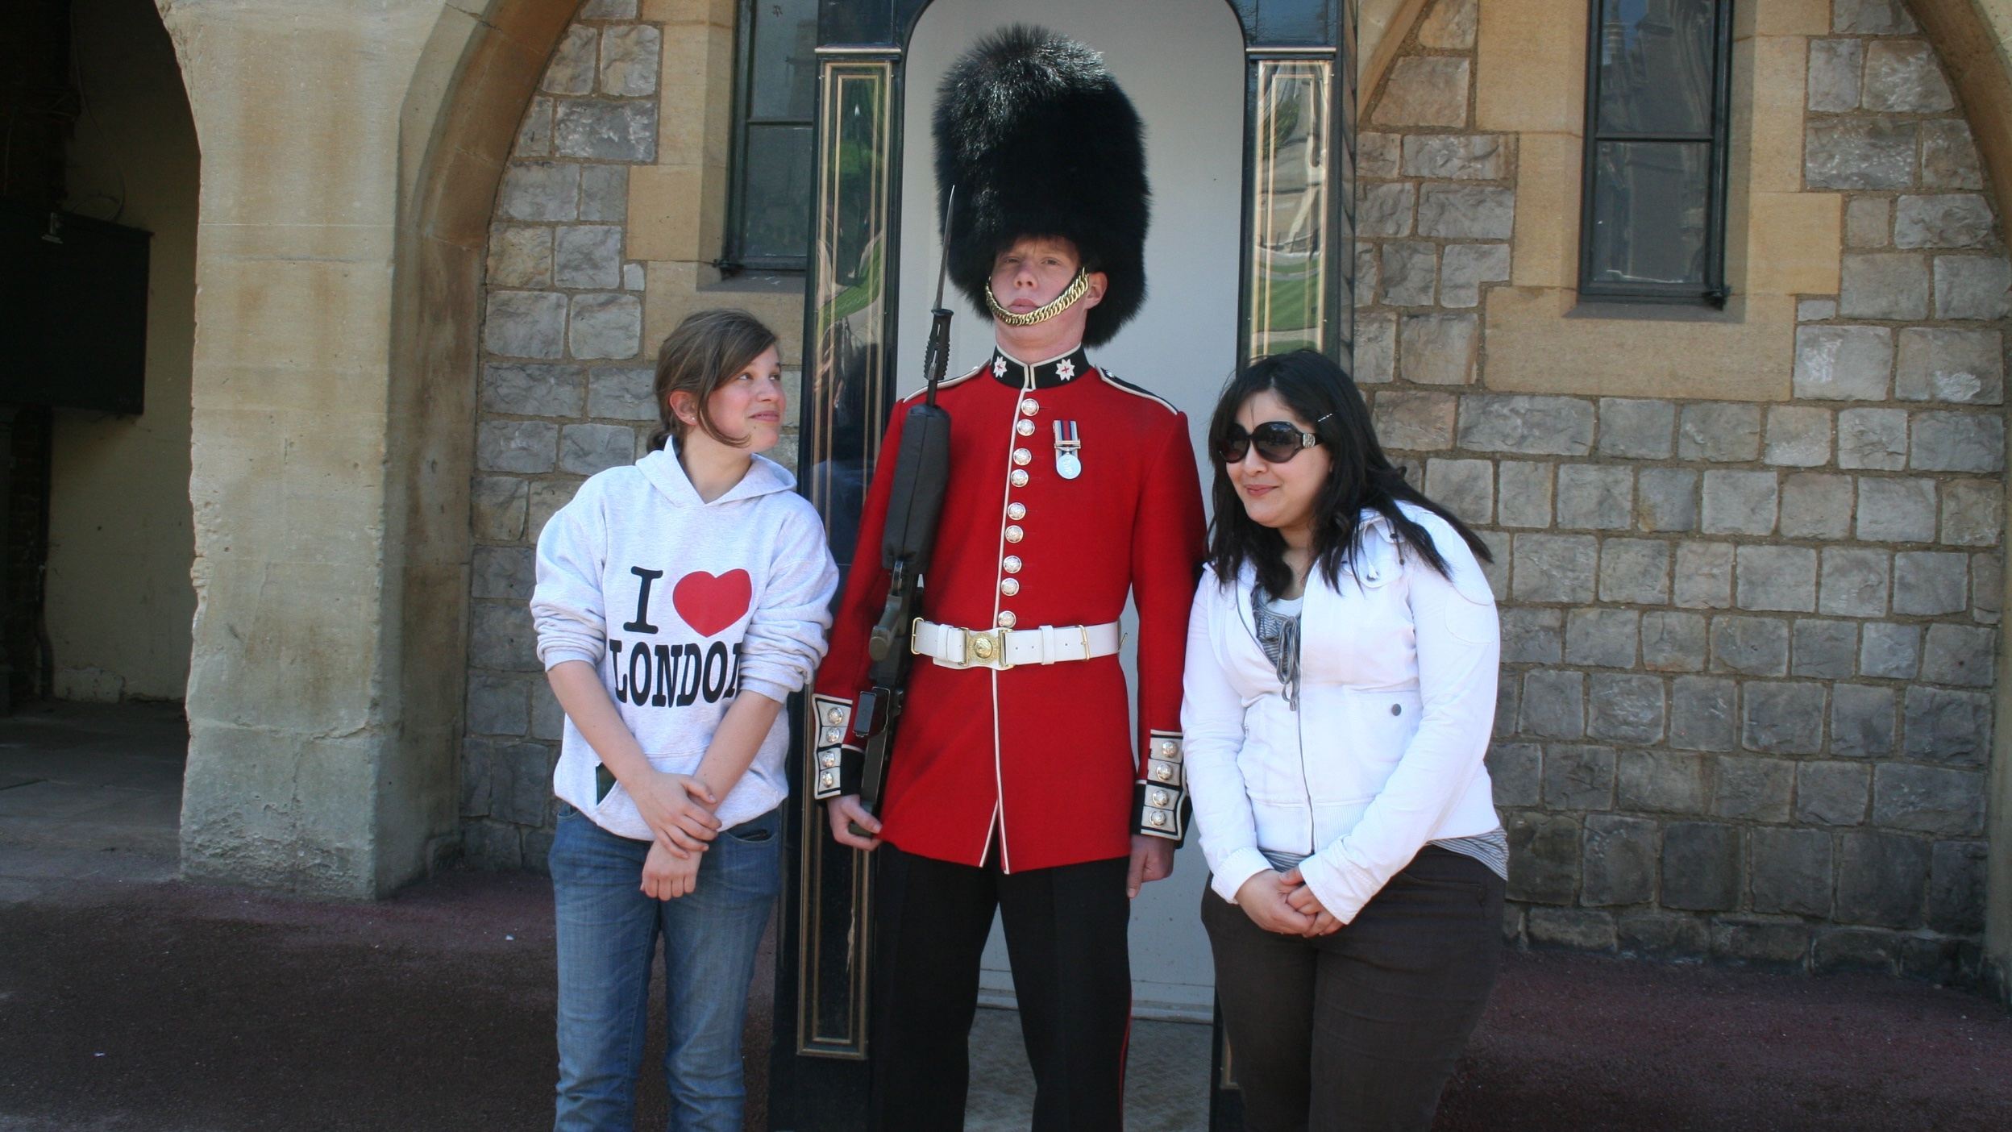

Longridge Road, London SW5 9SB, UK, from 14 to 17 age

Course intensity | 0
Accommodation | Hostel
Room type | Multi-bedded
Bathroom facilities | Shared
Meals | Breakfast, Lunch and Dinner
Excursions per week | 3
Weekday excursions | 6
Full day excursions | 2

Description

Why choose this program

Infrastructure

Sport infrastructure

Hobbies and clubs

What else included in the program price

Recommended arrival city

Лондон

Sample timetable
 | Morning | Afternoon | Evening
Day 1 |  | ARRIVAL TO UNITED KINGDOM
Day 2 |  | Interactive English workshop
Day 3 |  | Interactive English workshop
Day 4 |  | Interactive English workshop
Day 5 |  | Interactive English workshop
Day 6 |  | Interactive English workshop
Day 7 |  | Interactive English workshop

For booking please go to www.travelclass.org

