NOTTINGHAM

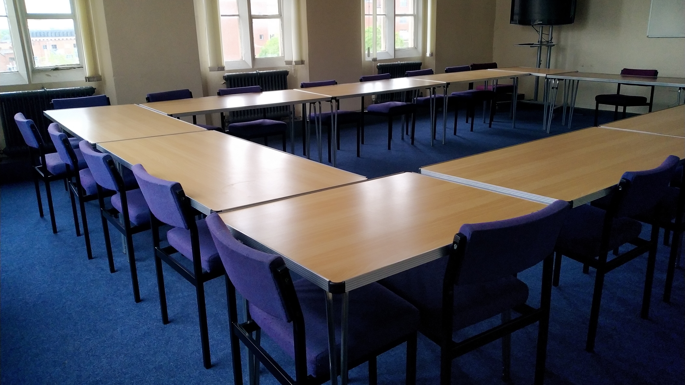

Nottingham, UK, from 11 to 17 age

Course intensity | 24
Accommodation | Host family
Room type | Single
Bathroom facilities | Shared
Meals | Breakfast, Lunch and Dinner
Excursions per week | 1
Weekday excursions | 1
Full day excursions | 0

Description

Why choose this program

Infrastructure

Sport infrastructure

Hobbies and clubs

What else included in the program price

Recommended arrival city

Лондон

Sample timetable
 | Morning | Afternoon | Evening
Day 1 |  | ARRIVAL TO THE UK
Day 2 | English Test & English Language Classes | Orientation in the town centre | Family time !
Day 3 | 3 hours English Language classes | Afternoon of Games | Family time !
Day 4 | Full Day Excursion to Oxford or London | Some free time for Shopping
Day 5 | 3 hours English Language classes | Afternoon of Games | Family time !
Day 6 |  | Day spent with the Host Family
Day 7 |  | Day spent with the Host Family

For booking please go to www.travelclass.org

