IP Bournemouth - escola d'idiomes al Regne Unit

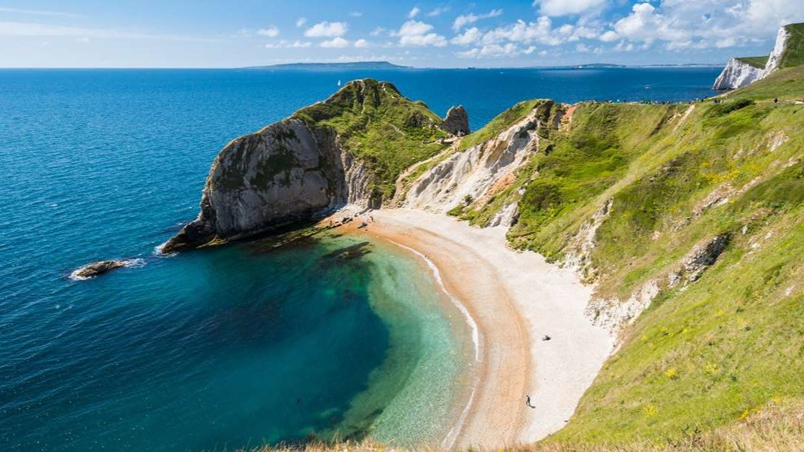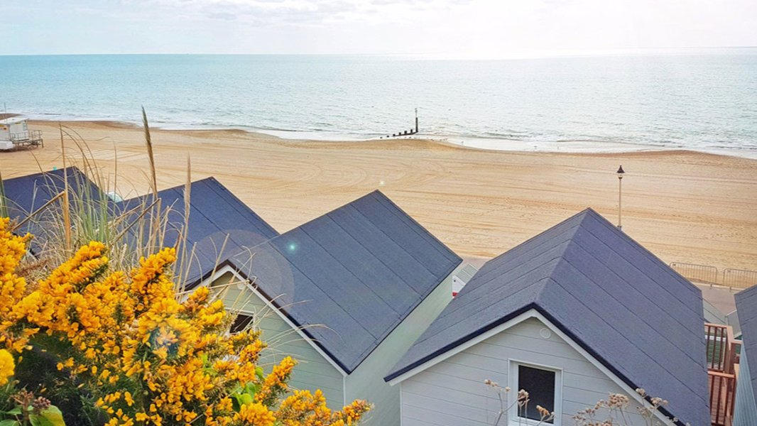

Europa School of English, Knole Road, Bournemouth, UK, from 12 to 17 age

Course intensity | 15
Accommodation | Host family
Room type | Twin
Bathroom facilities | En-suite
Meals | Breakfast, Lunch and Dinner
Excursions per week | 3
Weekday excursions | 2
Full day excursions | 1

Description

Why choose this program

Infrastructure

Sport infrastructure

Hobbies and clubs

What else included in the program price

Recommended arrival city

Лондон

Sample timetable
 | Morning | Afternoon | Evening
Day 1 | Arrival | Arrival | Arrival
Day 2 | English lessons | BASKETBALL  TOURNAMENT | WEIRD  COSTUME  WELCOME  PARTY
Day 3 | English lessons | HD TRIP:  SOUTHAMPTON | CASINO NIGHT
Day 4 | English lessons | FRIENDSHIP  BRACELETS | MOVIE NIGHT
Day 5 | English lessons | HD TRIP  SALISBURY | WEREWOLVES  NIGHT
Day 6 | English lessons | TOWN WALK | KARAOKE  FAREWELL  EVENING
Day 7 | LONDON  TRIP | LONDON  TRIP | LONDON  TRIP

For booking please go to www.travelclass.org

