TLA Miami Summer Program - Barry University

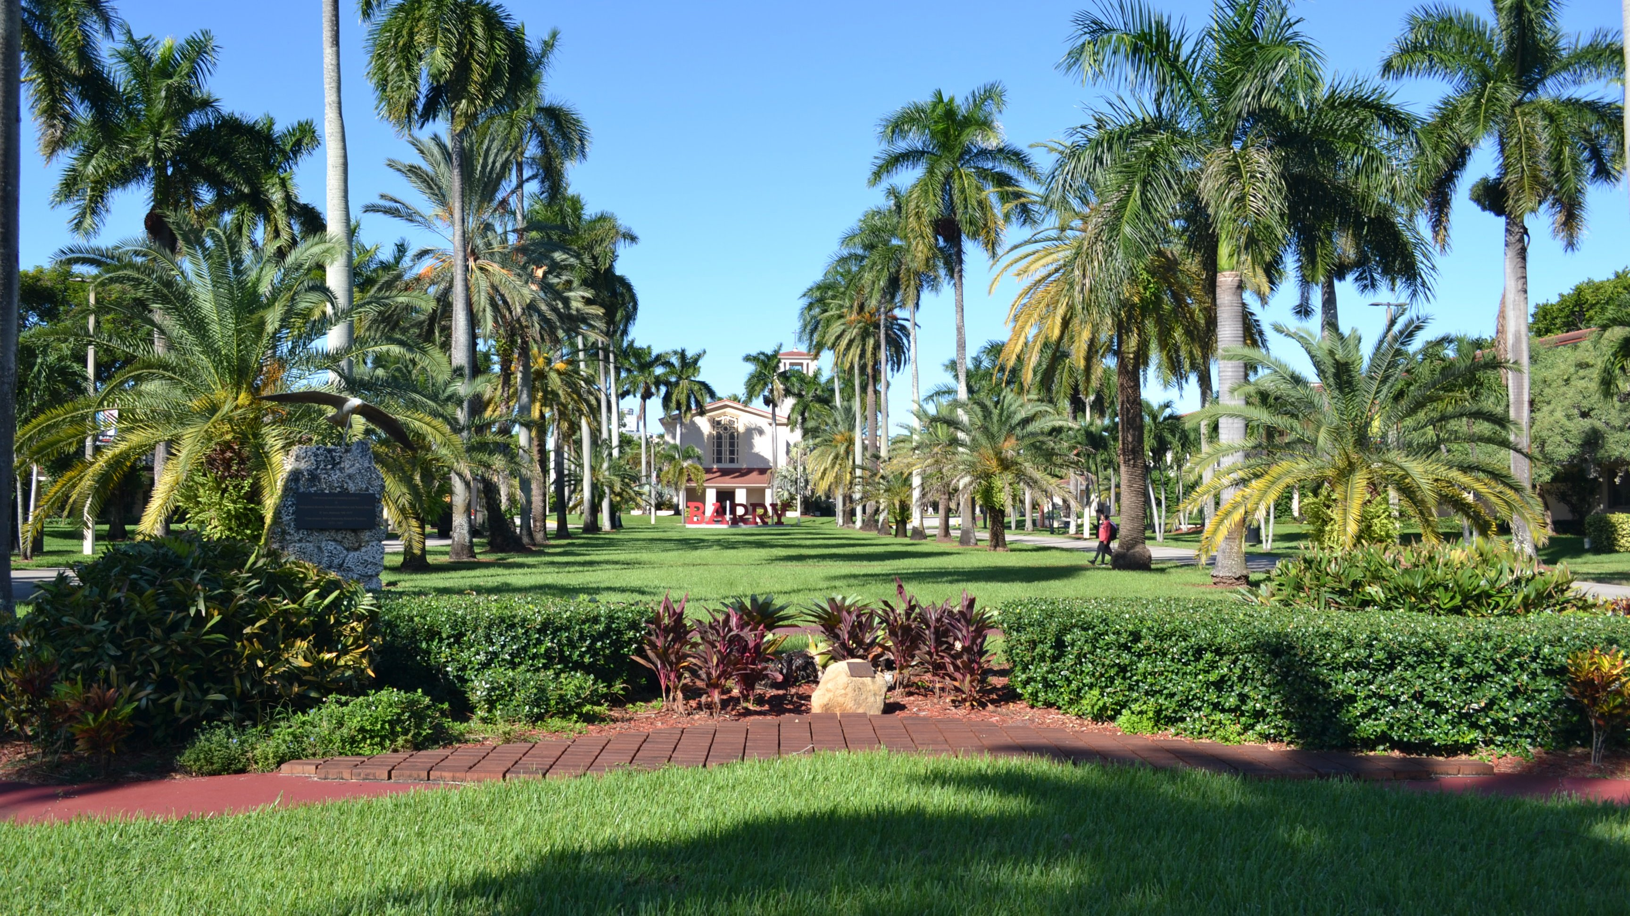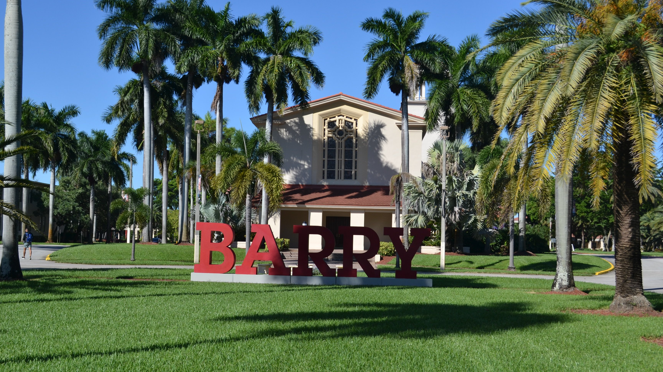

Barry University, Northeast 2nd Avenue, Miami Shores, FL, USA, from 15 to 18 age

Course intensity | 15
Accommodation | Campus
Room type | Twin
Bathroom facilities | En-suite
Meals | Breakfast, Lunch and Dinner
Excursions per week | 6
Weekday excursions | 5
Full day excursions | 1

Description

Why choose this program

Infrastructure

Sport infrastructure

Hobbies and clubs

What else included in the program price

Recommended arrival city

Sample timetable
 | Morning | Afternoon | Evening
Day 1 |  | Arrival day
Day 2 | Orientation, Testing & Campus Tour | Miami South Beach | Lincoln Road at night
Day 3 | Classes | Miami Wynwood Design District | Various evening activities
Day 4 | Classes | Fort Lauderdale Canals Cruise | Various evening activities
Day 5 | Classes | Sports Afternoon | Miami Marlins Baseball Game
Day 6 | Classes | Miami Tour and Bayside | Dinner at Hard Rock Cafe
Day 7 | Nasa | Nasa | Free time
Day 8 | Free time | Sawgrass Mills Mall | Free time
Day 9 | Classes | Red Reef State Park - Boca Raton | Various evening activities
Day 10 | Classes | Key Biscayne | Various evening activities
Day 11 | Classes | Everglades Gator Park | Various evening activities
Day 12 | Classes | Fort Lauderdale Beach | Dinner at Bubba Gump
Day 13 | Classes | Pool & Sports afternoon | Brickell City Center
Day 14 |  | Departure day

For booking please go to www.travelclass.org

