The Language Academy - school of English in Florida

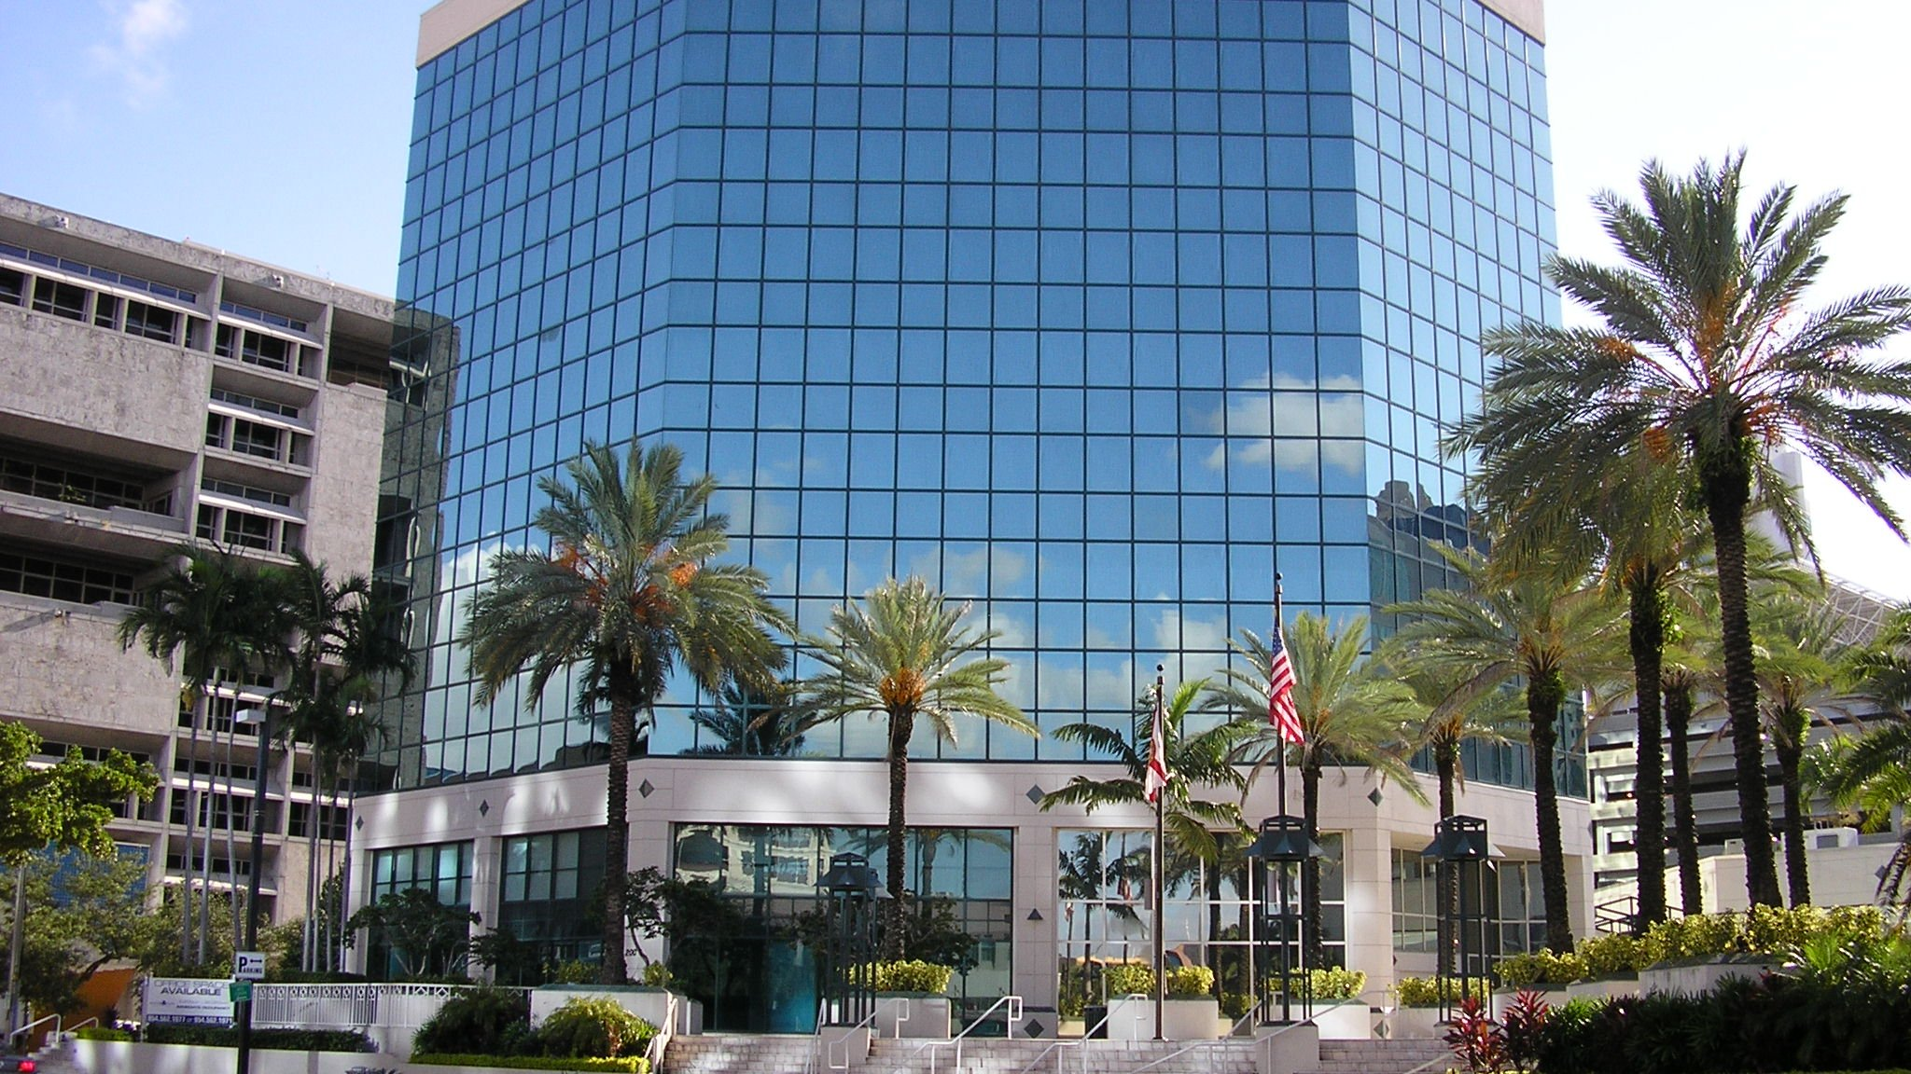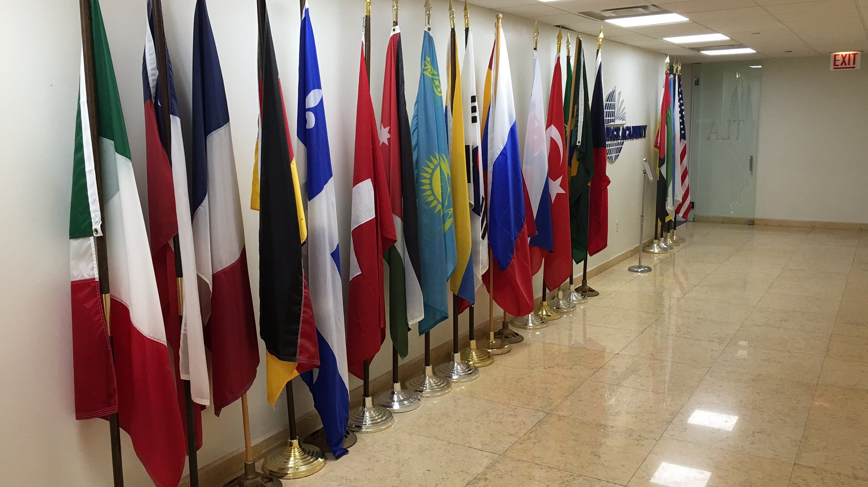

200 South Andrews Avenue, Fort Lauderdale, FL, USA, from 15 to 18 age

Course intensity | 15
Accommodation | Hotel
Room type | Triple
Bathroom facilities | En-suite
Meals | Breakfast, Lunch and Dinner
Excursions per week | 6
Weekday excursions | 5
Full day excursions | 1

Description

Why choose this program

Infrastructure

Sport infrastructure

Hobbies and clubs

What else included in the program price

Recommended arrival city

Майами

Sample timetable
 | Morning | Afternoon | Evening
Day 1 | Arrival day
Day 2 | Orientation, Testing & Downtown Walking Tour | Canals Cruise & Las Olas Walk | Free time
Day 3 | Lessons | Miami South Beach | Miami South Beach
Day 4 | Lessons | Wynwood Design District | Free time
Day 5 | Lessons | Pool Afternooon | Miami Marlins Baseball game
Day 6 | Lessons | Aventura Mall | Lincoln Road
Day 7 | Kennedy Space Center | Kennedy Space Center | Free evening
Day 8 | Miami City Tour | Miami City Tour | Dinner at Hard Rock Café
Day 9 | Lessons | Red Reef State Park & Beach (Boca Raton) | Free time
Day 10 | Lessons | Sawgrass Mills Outlet Mall | Sawgrass Mills Outlet Mall
Day 11 | Lessons | Everglades Gator Park | Free time
Day 12 | Lessons | Fort Lauderdale Beach | Dinner at Bubba Gump
Day 13 | Lessons | Key Biscayne | Brickell City Center
Day 14 | Departure

For booking please go to www.travelclass.org

