ILC Cambridge - Escola d'anglès al Regne Unit

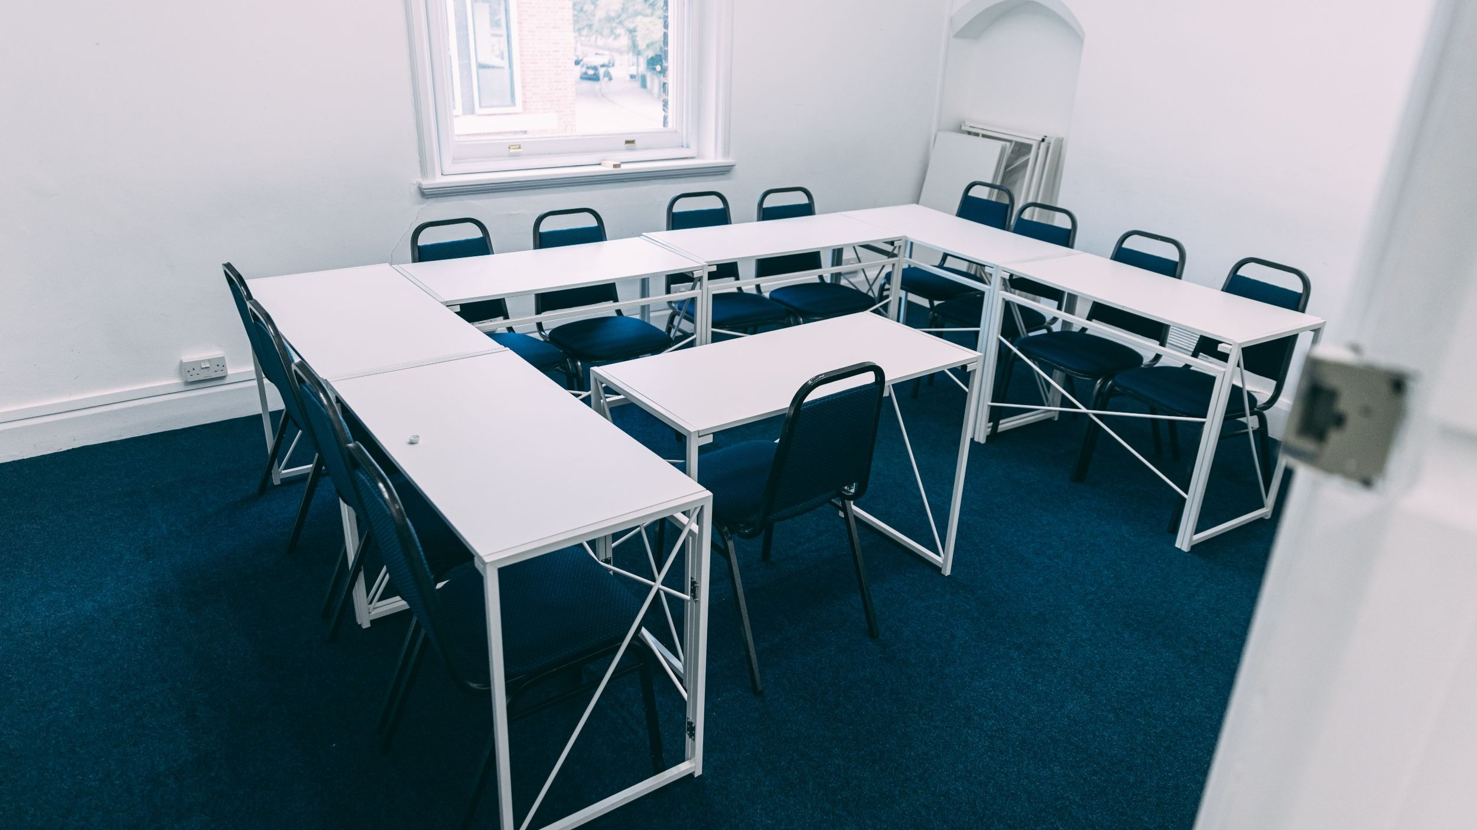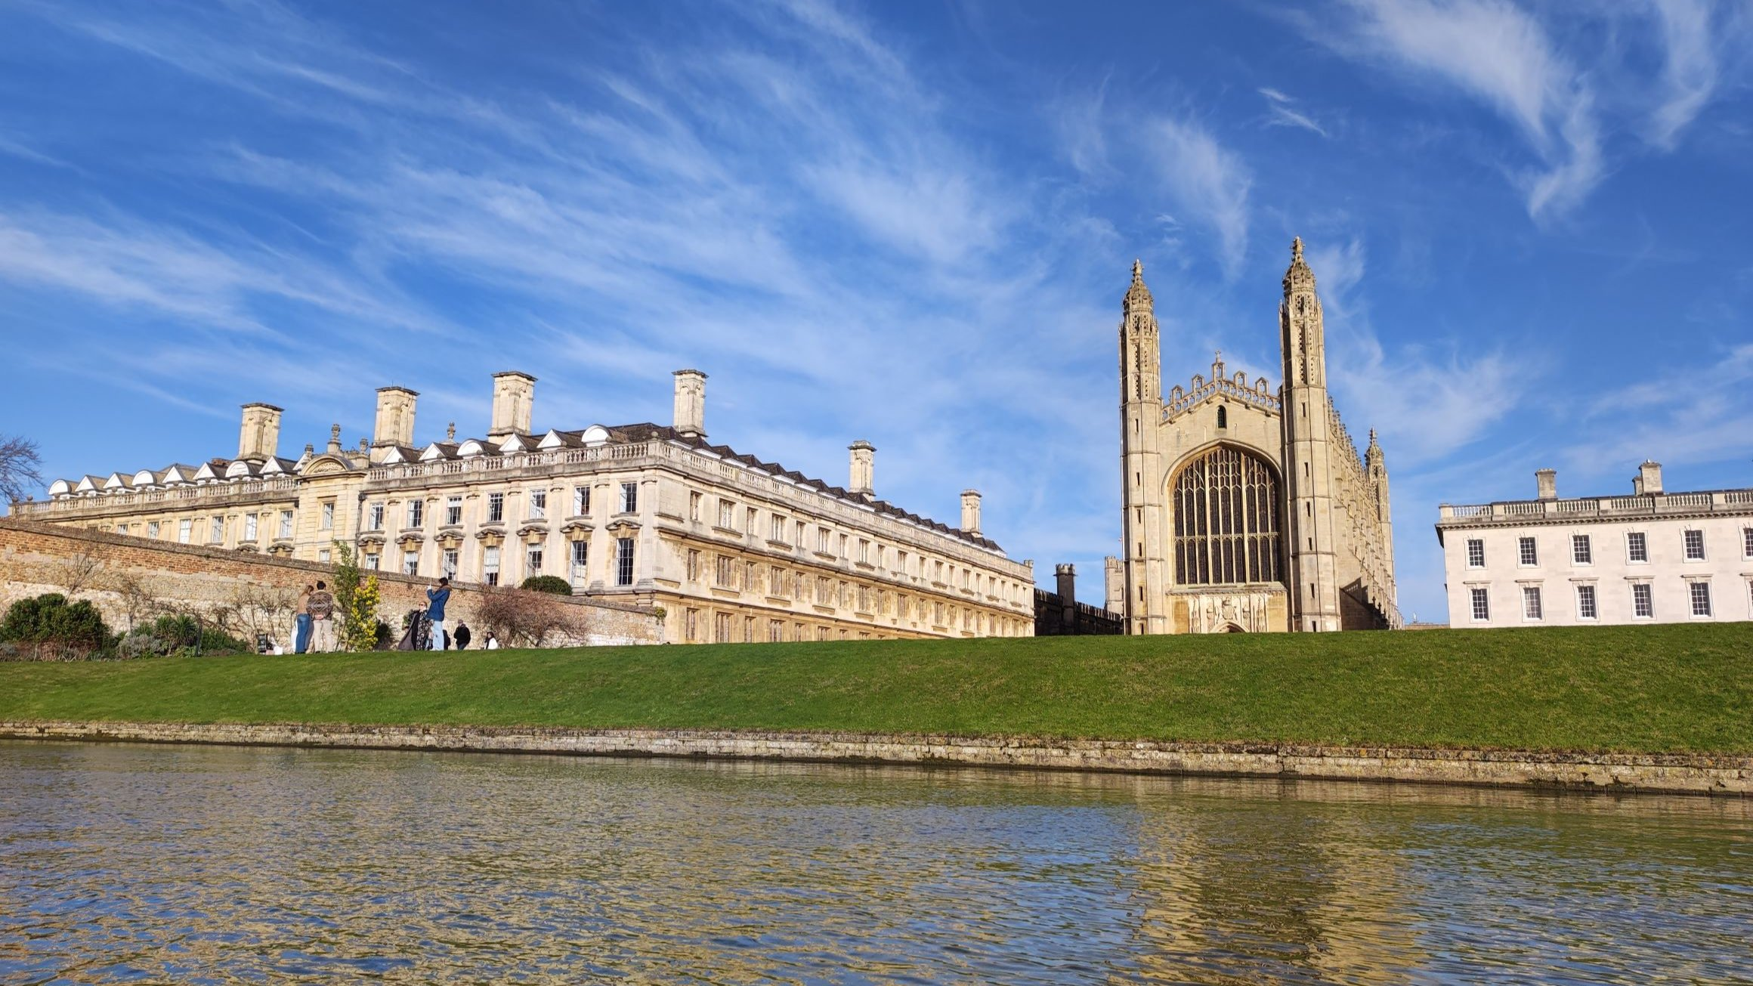

ILC Cambridge, Park Street, Cambridge, UK, from 11 to 17 age

Course intensity | 15
Accommodation | Host family
Room type | Twin
Bathroom facilities | Shared
Meals | Breakfast + Dinner
Excursions per week | 2
Weekday excursions | 1
Full day excursions | 1

Description

Why choose this program

Infrastructure

Sport infrastructure

Hobbies and clubs

What else included in the program price

Recommended arrival city

Лондон

Sample timetable
 | Morning | Afternoon | Evening
Day 1 | Arrival | Arrival | Arrival
Day 2 | Lessons | Cambridge Tour | Free time with a host family
Day 3 | Lessons | Speaking club | Free time with a host family
Day 4 | Lessons | Conversation club | Free time with a host family
Day 5 | Lessons | Games | Free time with a host family
Day 6 | Lessons | Movie time | Free time with a host family
Day 7 | Excursion  to London | Excursion  to London | Excursion  to London

For booking please go to www.travelclass.org

