Atlas Language School - language school in Malta

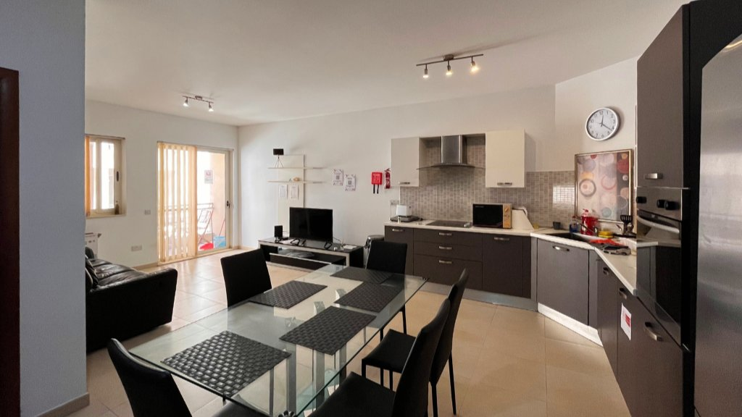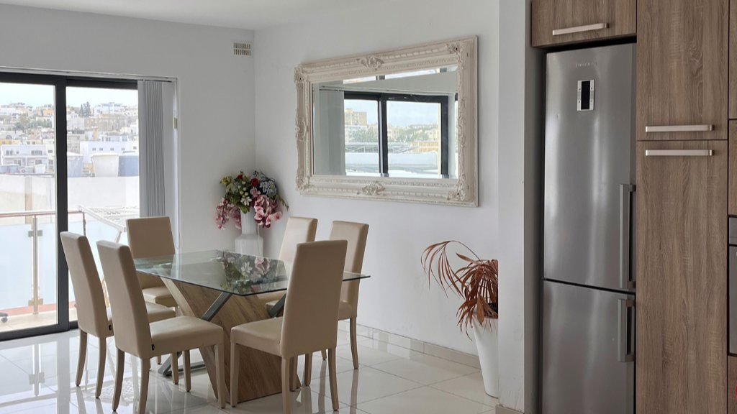

Atlas Language School, Pembroke, Malta, from 18 to 99 age

Course intensity | 15
Accommodation
Room type | Single
Bathroom facilities
Meals
Excursions per week
Weekday excursions
Full day excursions

Description

Why choose this program

Infrastructure

Sport infrastructure

Hobbies and clubs

What else included in the program price

Recommended arrival city

Sample timetable
 | Morning | Afternoon | Evening
Day - | - | - | -

For booking please go to www.travelclass.org

