Lexis Kobe - language school in Japan

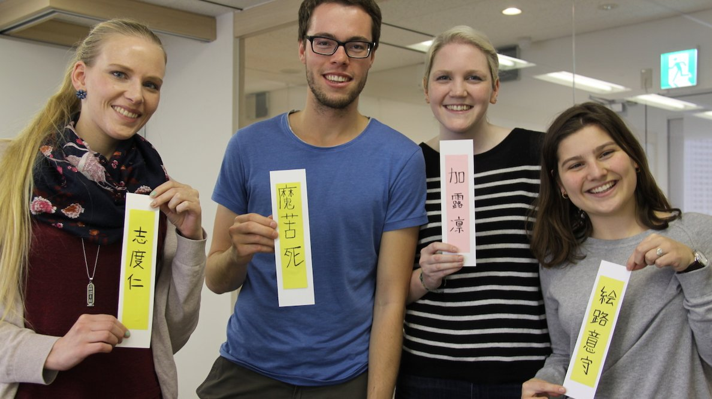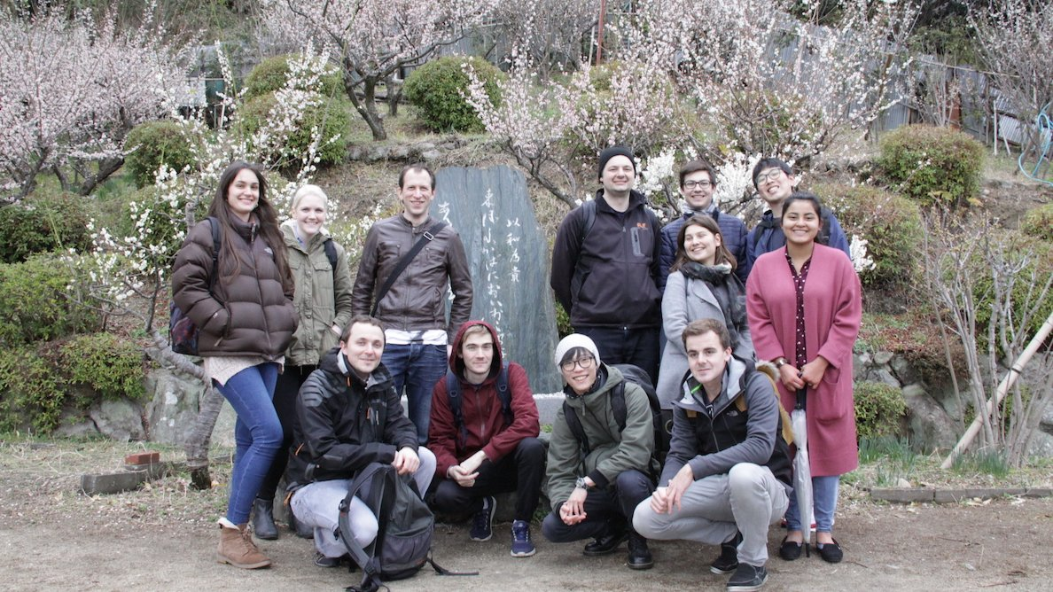

Japan, 〒650-0038 Hyogo, Kobe, Chuo Ward, Nishimachi, 36 三菱ＵＦＪ信託銀行神戸ビル, from 13 to 17 age

Course intensity | 15
Accommodation | Host family
Room type | Single
Bathroom facilities | Shared
Meals | Breakfast, Lunch and Dinner
Excursions per week | 1
Weekday excursions | 1
Full day excursions | 1

Description

Why choose this program

Infrastructure

Sport infrastructure

Hobbies and clubs

What else included in the program price

Recommended arrival city

Кобе

Sample timetable
 | Morning | Afternoon | Evening
Day 1 | Lessons | Local Tour. On their first day, students are taken on an afternoon tour so they can be introduced to Motomachi/Sannomiya  areas of Kobe. Lively towns with a large shopping arcade, China town district and gourmet cuisine. | Time with a host family
Day 2 | Lessons | Kobe Animal Kingdom. The Kobe Animal Kingdom is a very special place where you can really sense nature. Inside the greenhouse, there  are hundreds of plants and flowers hung from the ceiling and they are just beautiful. You will get to feed animals  and birds, and pat them too! | Time with a host family
Day 3 | Lessons | The Ramen Museum. Students will experience how cup noodles are produced as they knead, stretch and flavour flour making their very  own chicken ramen. Students will also be able to wander through the museum and discover the history of the  world’s first instant noodle, invented in Ikeda, Japan. | Time with a host family
Day 4 | Lessons | Karaoke Competition. Join Karaoke! One of Japan’s favourite past times. Sing your favourite songs in the comfort of soundproof rooms.  Don’t be shy! We can sing all together! | Time with a host family
Day 5 | Lessons | Osaka Castle. Osaka Castle is one of the most famous castles in Japan. It played a major role in the unification of 16th-century  Japan. Take a step back in time and experience what life would have been like living in Osaka Castle, or take a walk  through the famous Osaka Castle Gardens. | Time with a host family
Day 6 | Weekend | Weekend | Time with a host family
Day 7 | Weekend | Weekend | Time with a host family
Day 8 | Lessons | Local Tour or Free Time. Students will have the opportunity to explore the surrounding areas of Motomachi and Sannomiya. | Time with a host family
Day 9 | Lessons | Osamu Tezuka Manga Museum: The Creator of Astro Boy. The Tezuka Osamu Manga Museum in Takarazuka is where the world-famous manga creator of Astro Boy lived for 20 years. The museum has many exhibitions about the life of the artist along with his visions for the creation of Astro Boy. | Time with a host family
Day 10 | Lessons | Cooking Class. A chance to learn how to cook some traditional Japanese dishes. Learn how to cook it and let’s have nice Japanese  lunch together. Don’t forget to cook it for your family and friends when you go back to your country | Time with a host family
Day 11 | Lessons | Bowling Competition. Time for some fun indoor exercise! A great fun activity on a hot summer’s day. Win some prizes in a special time-limit event! Go get a strike!!! | Time with a host family
Day 12 | Lessons | Pop Culture in West Japan. Take a visit to Osaka, the pop culture capital of West Japan. Visit the areas of Nipponbashi and Namba and experience  the excitement of Japanese pop culture first-hand. | Time with a host family
Day 13 | Weekend | Weekend | Time with a host family
Day 14 | Departure | Departure | Departure

For booking please go to www.travelclass.org

