British Culture — English language camp in Turkey

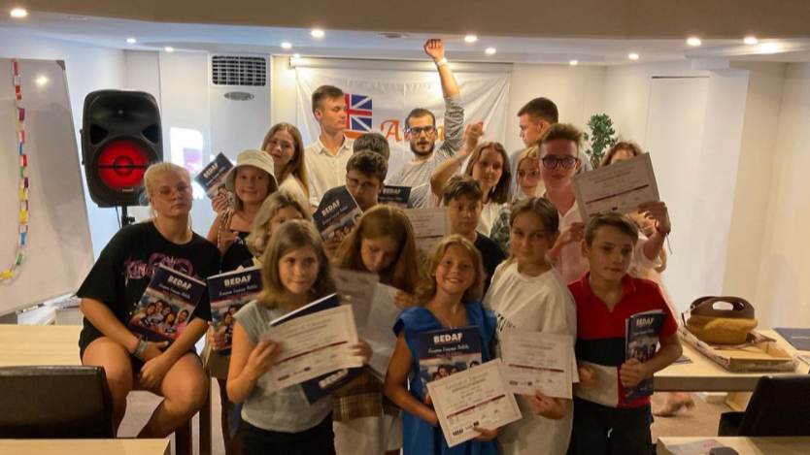

Deniz Caddesi No: 25, 07990 Кемер, Турция, from 9 to 16 age

Course intensity | 20
Accommodation | Hotel
Room type | Triple
Bathroom facilities | En-suite
Meals | Breakfast, Lunch and Dinner
Excursions per week | 1
Weekday excursions | 1
Full day excursions | 0

Description

Why choose this program

Infrastructure

Sport infrastructure

Hobbies and clubs

What else included in the program price

Recommended arrival city

Анталья

Sample timetable
 | Morning | Afternoon | Evening
Day 1 | Arrival day
Day 2 | Free time at the beach/pool
Day 3 | Lessons
Day 4 | Lessons | Cooking lesson | Cinema Night
Day 5 | Lessons | Beach | Free time
Day 6 | Lessons | Excursion to Aspendos | Conversational club
Day 7 | Lessons | Beach/pool | Cinema
Day 8 | Departure
Day 9

Day 10

Day 11

Day 12

Day 13

Day 14

For booking please go to www.travelclass.org

